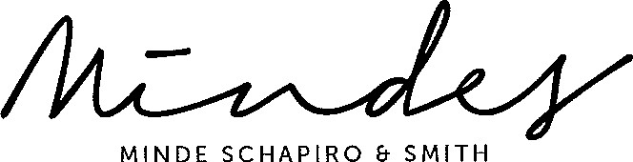
MINDE
SCHAPIRO
SMITH
Docex I I Tygerberg
PO Box 4040 | Tyger Valley 7536 | South Africa
Tyger Valley Office Park Building Number 2 | Cnr Willie van Schoor & Old Oak Roads I Bellville
T: 021 918 9000 021 918 9020 (Direct Line) I F: 021 918 9070 (General) | 0866131061 (Direct Fax)
E: elzanne@mindes.co.za www.mindes.co.za our Ref: DEMI 6/0086/ELZANNE JONKER/sw I Your Ref: Adv S Abrahams I Date: 31 January 2018
Adv Shaun Abrahams
National Director of Public Prosecutions
Victoria & Griffiths Mxenge Building
1 23 Westlake Avenue
Weavind Park
Silverton
PRETORIA
0001
Email: ndpp@npa.gov.za

Dear Adv Abrahams
EXTANT CHARGES AGAINST PRESIDENT JACOB ZUMA
We refer to the above matter, and your correspondence signed 10 December 201 7.
- We note that the date of the extension you granted Pres Zuma is today, 31 January 201 8 and we trust you are now in possession of these representations.
- We now request and insist that the DA and other interested parties be given an opportunity of 1 4 calendar days to comment on Pres Zuma's further representations.
- We look forward to receipt of the representations urgently.
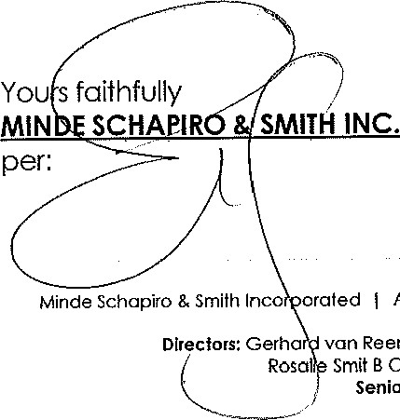
Attorneys Notaries Conveyancers & Mediators since 1926 | Registration number 2010/025182/21
Reenen
Louis Meyer B Juris LLB I Heinrich Crous BA LLB I Samantha Solomons B Proc
Smit B Comm LLB I Elzanne Jonker BA LLB I Jonathan Rubin B Comm LLB LIM Senior Associates: Gerhard Lourens FPSAO I Venesen Reddy LLB BA LLB
Consultant: Marianne Olivier B Comm LLB LLM
Vat regisfrafion number: 4580257428 | Also at Greenacres, Port Elizabeth

