QUESTION FOR WRITTEN REPLY

NAME OF MEMBER PUTTING QUESTION: **I. Keeka (DA)**

QUESTION ADDRESSED TO: **MEC for Health**

QUESTION:

For Written Response

1. How many Primary healthcare mobile hospitals were procured by the department;
2. In which districts are these mobile hospitals placed;
3. How many in each district as in the districts listed in 2;
4. What is the cost of each unit and attached unit separately;
5. What equipment is fitted in each unit as well as the attached unit where available ;
6. Were the mobile hospitals procured through a tender process;
7. If yes, which company was awarded the tender;
8. At what price was the tender awarded;
9. Is there a maintenance contract for these units and attachments;
10. If yes, what is the annual cost to the department for maintenance ;
11. How many patients were seen, up to and including even date, by these units and attachments [list per district];
12. Are any of these units or the attachments currently in need of repair or being repaired as of even date;
13. Please provide a copy of the maintenance contract if one is entered into;
14. If no such contract is entered into, referred to in 13, why not;
15. If there is such a contract as referred to in 13, what is the duration of the contract?

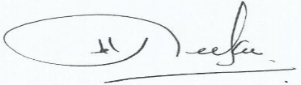

**………………………………………………………….**SIGNATURE OF MEMBER GIVING NOTICE OF THE QUESTION

DATE: 10 December 2014…………………