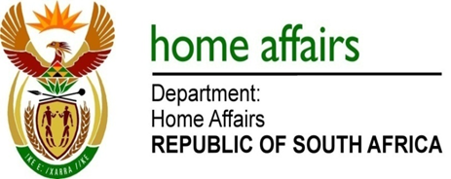

NATIONAL ASSEMBLY

QUESTION FOR WRITTEN REPLY

QUESTION NO. 105.

DATE OF PUBLICATION: THURSDAY, 08 FEBRUARY 2018

Ms L V James (DA) to ask the Minister of Home Affairs:

With regard to the reply to question 3517 on 24 November 2017, (a) how many people are employed at the Inspectorate Unit, (b) where are they based and (c) what is the budget of the unit? NW111E

REPLY:

(a) The number of officials employed in the Inspectorate is 731
(b) They are based at all Home Affairs offices in South Africa.
(c) The budget for the Inspectorate is R179,744,000.

