Office of Councillor Cecilia A Auld
9 Napier Street
Bedford
5780

14 August 2018
Via Email: linda.sigwili@eclgta.gov.za

The Hon MEC
Mr Fikile Xasa
Co-operative Governance & Traditional Affairs
P Bag X0035
BHISHO
5605

Cc: Hon Minister, Dr Zweli Mkhize,
Minister of Cooperative Governance and Traditional Affairs
Via email to: GeorginaS@cogta.gov.za
Dear Mr Xasa

RE: CONTINUING FAILURE OF MANAGEMENT TO ADDRESS THE
DIRE SITUATION IN RAYMOND MHLABA MUNICIPALITY

Further to my letters to you on 6 September 2017, 9 May and 11 June 2018, for which I have never received a response or acknowledgement,, I write to you again about my continuing concerns regarding the untenable situation here in Bedford/Raymond Mhlaba Municipality and the failure of the Municipal Manager and the Mayor, for many months now, to resolve the matter.

In addition to several meetings between the Mayor, Municipal Manager and Speaker by members of the Bedford Resident’s Association over the past weeks and the numerous letters and emails I have sent to the Mayor requesting his urgent intervention, no action has been taken to resolve the matter!

The Mayor and Municipal Manager are using the excuse that they are ‘afraid’ for their lives as a reason NOT to engage with the community – a weak excuse as the protesters have given an undertaking that they will not harm anyone!

Instead the Municipal Manager has arranged for approximately 8 SAPS Public Order Police to protect the Town Hall so that staff can return to work but this can hardly be seen as trying to resolve the matter. No member of the community will risk entering these premises.

In any case, the same SAPS could be better used to protect the Mayor and Municipal Manager if and when they engage with the community - as could the municipality’s own security guards! As I said – a weak excuse indeed!

As I write the community are mobilizing yet again to take to the streets in protest.

The Mayor and Municipal Manager’s failure to resolve the stalemate has led to an ever-increasing anger amongst the community protesters and has also led to deep dissatisfaction and distrust amongst the paying public!

Protests are taking place every 3 or so days and have been going on since the middle of last year!

Services - like refuse collection - have not been carried out for almost 3 months now. Regular infrastructure maintenance has not been done for over 18 months. No staff are working and the community are insisting that the municipal offices remain closed until such time as they are engaged with.

The protesters of Bedford have legitimate grievances as do the ratepayers and general community.

How much longer are they to be ignored?

How much longer must the public be held to ransom by the municipality’s failure to address this problem?

Please Sir - I humbly ask that once again you give your full attention to the contents of this letter and the increasing problem here –your intervention is again urgently required!

Yours sincerely

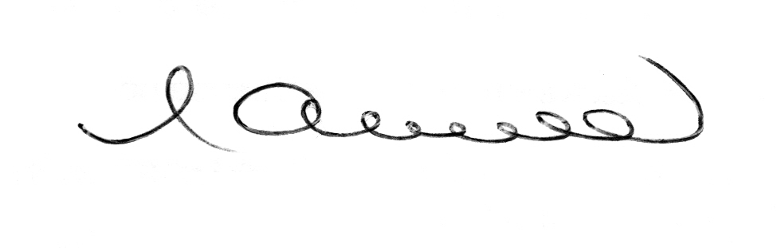
CECILIA AULD
PR COUNCILLOR: RAYMOND MHLABA MUNICIPALITY
DEMOCRATIC ALLIANCE : BEDFORD

