Motion in terms Rule 121 read with Rule 122: Motion on the payment of compensation of the families of the victims of the Life Esidimeni tragedy which falls under the jurisdiction of the Office of the Premier:

Noting:

1. That the Life Esidimeni tragedy led to the loss of 144 lives and suffering for hundreds of mental health patients who survived;
2. That R159.46 million has been paid to victims who were part of the arbitration process presided over by Justice Dikgang Moseneke;
3. That more money has been paid to additional claimants who have since come forward;

and Believing:

That all avenues should be followed to ensure maximum accountability from those who were responsible for this tragedy;

Therefore Resolves:

1. That in addition to other legal processes, the Gauteng Provincial Government takes legal advice on using the Apportionment of Damages Act to recover some of the compensation money from former Health MEC, Qedani Mahlangu, former Head of Department, Barney Selebano and former Chief Director: Mental Health, Makgabo Manamela.

2. That the Honourable Premier report back to this House on this matter within 60 days, including whether he will seek to make the Arbitration Award an order of the court so that proceedings under the Act can go ahead to recover the money.

Proposed: 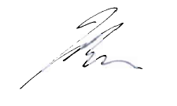
Jack Bloom MPL

Seconded: 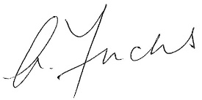
Alan Fuchs MPL

