Motion in terms Rule 121 read with Rule 122: Motion on violent crime in Gauteng

Noting that:
- South Africa is currently experiencing an unprecedented increase in violent attacks and murders which pose a threat to rural communities in Gauteng
- Rural communities are 4 times more likely to be the victims of violent crime compared to the average urban citizen
- The decline of the mining sector in Gauteng is having a further effect on rural safety
- There is currently no coherent, focussed and resourced strategy to effectively deal with these types of crimes

Believing that:
- Agricultural communities, including agricultural entrepreneurs, employees, and their families are a national asset that contribute to food security and biodiversity

- The agricultural sector in Gauteng must be adequately supported to ensure its sustainability, growth and contribution to the GDP of the province and that includes an effective strategy to deal with violent crimes that affect rural communities
- Each day that passes brings yet another attack and hence this matter is extremely urgent in view of the threat to human life and the threat to human food security in respect of(i) above.

Therefore, resolves to call on the GPL to debate:
- Appropriate and holistic policy responses by provincial government that will lead to Innovative and sustainable measures to effectively ameliorate the current spate of violent attacks and murders perpetrated in Gauteng
- Long term, holistic strategies involving whole communities and all relevant government departments, to safeguard and protect our agricultural assets and communities in Gauteng.
- The need for the provincial government to invest in technological innovation that can be made available to rural communities to enhance their safety.

Proposed: 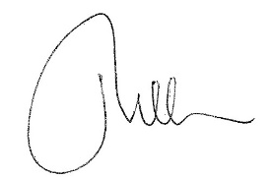
Ina Cilliers MPL
Seconder: 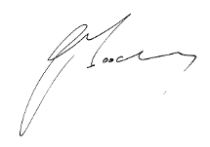
John Moodey MPL

