QUESTIONS FOR WRITTEN REPLY
NAME OF MEMBER PUTTING THE QUESTION; HON. B. SINGH (DA)
QUESTION ADDRESSED TO; MEC for Arts and Culture
QUESTION;
For Written Response
A Department of Arts and Culture Vehicle, a VW Eco, was filmed driving through Durban on Saturday 9 November 2019, with both its side doors wide open, with passengers whom are allegedly not officials of the department apparently consuming alcohol and smoking.

1. Is the Department aware that the vehicle, with the department's branding and registration number KZN 82187, was seemingly being used by non-officials that were consuming alcohol;
2. What is the department’s policy on private use of government vehicles;
3. Are department official vehicles monitored and logged;
4. Will the Department investigate the matter and make a statement?

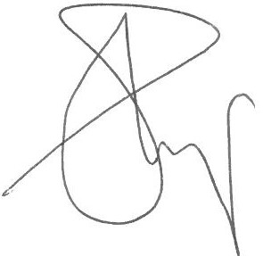

SIGNATURE OF MEMBER GIVING QUESTION…………………..
DATE: 14 October 2019……………………………………………………

