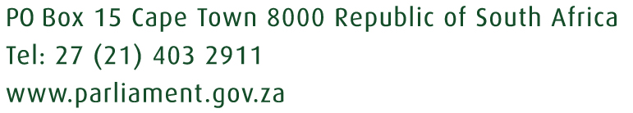

DEAN WILLIAM MACPHERSON MP

PO Box 15 Cape Town 8000 Tel: (021) 403-8641 Fax: (021) 461 0092
Cellphone: 083 776 0202 E-Mail: dean@eduform.co.za

19 March 2020

Department of Trade, Industry and Competition response to COVID-19
By: Dean Macpherson MP

There can be no doubt that COVID-19 is going to have an incredible impact on businesses in South Africa, especially those in the retail, manufacturing, agri-processing and credit markets.

This will be due to a massive downturn in local and international demand and the inability of the workforce to produce goods due to health and safety reasons.

With all of these industries requiring intense amounts of capital to be continually rotated through their business, the majority of which is borrowed (if not all, including credit for banks from the SARB), this could lead to large-scale defaults, a cash flow crisis and eventual closure.

It is therefore incredibly important that the DTI looks to use all available resources to stabilise the industrial, agricultural and banking sectors through a number of targeted means.

There are a number of ways that this can be done:

1 - A suspension, where possible on all state administered prices affecting manufacturing, imports and exports for Rail, port, toll fees, water and electricity costs. This should also apply to all rents that are paid to the state where businesses find themselves on state-owned land, in state-owned property, industrial parks, SEZ’s, IDZ’s ect

2 - Development Finance Institutions like the IDC, DBSA and NEF to make available 0% bridging finance to small and medium sized enterprises.

3 - An i12 tax allowance type of scheme which is a non-cash incentive on businesses to retain their workers and or invest in machinery to improve production efficiency to lower costs. There should be no investment financial amount to this as is budget neutral.

4 - Regulatory entities such as the NRCS, SABS and SANAS must not in any way be a blockage to business and should do everything possible to fast track all applications especially to those items which are low risk and for import and export as well as those items critical in the fight against COVID-19.

5 - The Credit Amendment Act should not be operationalised to allow for low-income South African’s to access much needed credit to survive day to day. This will loosen credit providers risk which has increased since the Act was signed and already had a major impact on credit provision to low-income people.

6 - There should be no load shedding during shopping hours or the weekend to allow for consumers to shop when needed.

7 - Load-shedding in industrial nodes should be suspended as far as possible.

8 - There cannot be a lock down of shopping centres as this would effectively bankrupt retailers.

9 - A moratorium on BEE to allow for state funding and incentives to go where needed and not only to majority black owned businesses as defined by Government. This is because the BEE Codes classify entities based on their annual turnover: Entities with a turnover of less than ZAR10 million are regarded as an exempted micro enterprise (EME). Entities whose turnover is more than R10 million, but less than R50 million are regarded as qualifying small enterprises (QSE). This means that any funding based on BEE qualifying criteria or ownership which is what all incentives are measured on, will miss over 93% of all companies which have a turnover of less than R10 million per year or not 51% black owned.

10 - Zero rated duty on alcohol for sanitiser production in SA as there is no local stock as well as zero duty on medical devices and equipment like masks and gloves used in the fight against COVID-19.

