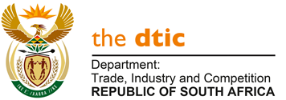

THE NATIONAL ASSEMBLY

QUESTION FOR ORAL REPLY

QUESTION NO. 255

Mr. M J Cuthbert (DA) to ask the Minister of Trade, Industry and Competition:

By what date does the National Lotteries Commission intend to provide information relating to its Covid-19 Relief Fund of R150 million to the Portfolio Committee on Trade, Industry and Competition as requested by the Committee? NO1587E

REPLY

I am advised by the National Lotteries Commission as follows:

“The National Lotteries Commission (NLC) went out on a call for applications for Coronavirus (COVID – 19) Relief Fund to the amount of R150 million and received over five thousand applications from non-profit organisations countrywide. At this stage, adjudications are underway and allocations are still being done on the R150 million to different applicants. Therefore, the process has not been completed as yet.

The NLC estimates that the whole process will be completed by the second week of July 2020 (17 July 2020). Only after that date can the NLC be able to provide a list of projects funded as part of COVID -19 relief.

In terms of the process, applications are received, processed in the system and prepared for adjudication by the respective Distributing Agencies respectively. After adjudication, those that have been successfully adjudicated are formally informed and Grant Agreements are prepared, and sent to the organization(s) for sign off. Beneficiaries are given a time frame of 30 days within which to sign and return formally signed Grant Agreements. Once Grant Agreements are received the NLC processes the agreements for payment and the law allows a period of 60 days within which to effect payment.”

-END-

