288. Hon. L Kleynhans (DA) asks the Hon. MEC responsible for PR&T: Mr. S Mashinini.

As a follow-up to question No 125 (IQP 2 – 2020);

288.1 How many farm attacks took place in the province between May and September 2020?

288.2 For the 118 cases which occurred during 2018/19; 2019/2020; and up to May 2020, what are the case numbers for each of these incidents?

288.3 How many of these cases have led to (a) prosecution and (b) conviction?
288.4 Have any cases been closed due to no investigation?

288.5 Has the Department identified specific geographical areas which are particularly problematic with regard to farm attacks, if not, why not, if so, what are the relevant details?

288.6 Has the Department identified specific weekdays or times when these attacks are most likely to occur, if not, why not, if so, what are the relevant details?

288.7 Is the Department co-operating with Free State Agriculture or District Farmers Associations to develop strategies to prevent farm attacks, if not, why not, if so, what are the relevant details?
288.8 How many vehicles are dedicated to farm attack and stock theft patrols in each police district?

288.9 Does South Africa have an extradition treaty with Lesotho to allow for perpetrators to be extradited to stand trial in South Africa, if not, why not, if so, what are the relevant details?

288.10 Are Free State SAPS allowed to enter Lesotho in pursuit of alleged farm attackers or stock thieves, or to recover stock and stolen goods, if not, why not, if so, what are the relevant details?

288.11 How many alleged farm attackers, farm murderers and stock thieves have been brought back to South Africa from Lesotho for trial?

NO RESPONSE
Converted to Oral: 13 Oct. 2020. No. 20
RESPONSE | 07/10/2020

Twenty seven (27) incidents of violence on farms and smallholdings (farm attacks) took place between 1 May 2020 and 17 September 2020.

288.2 For the 118 cases which occurred during 2018/19; 2019/20; and up to May 2020, what are the case numbers for each of these incidents? 288.3 How many of these cases have led to; (a) prosecution (b) conviction?
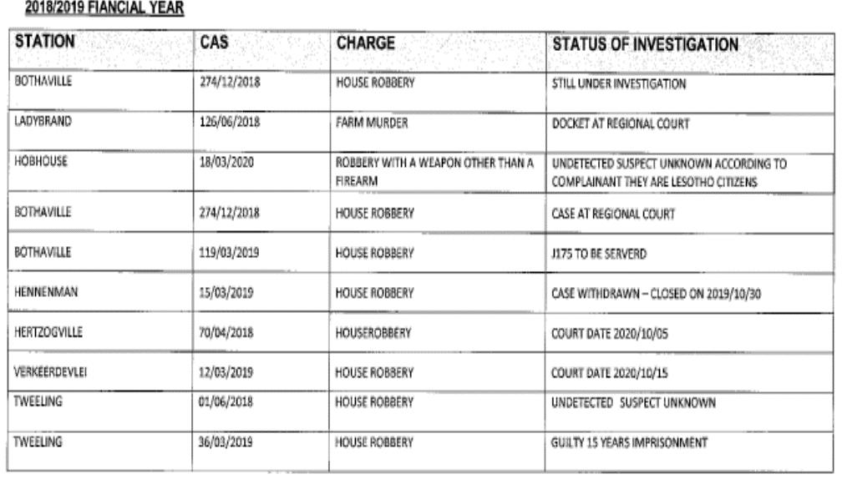

2018/2019 Continued

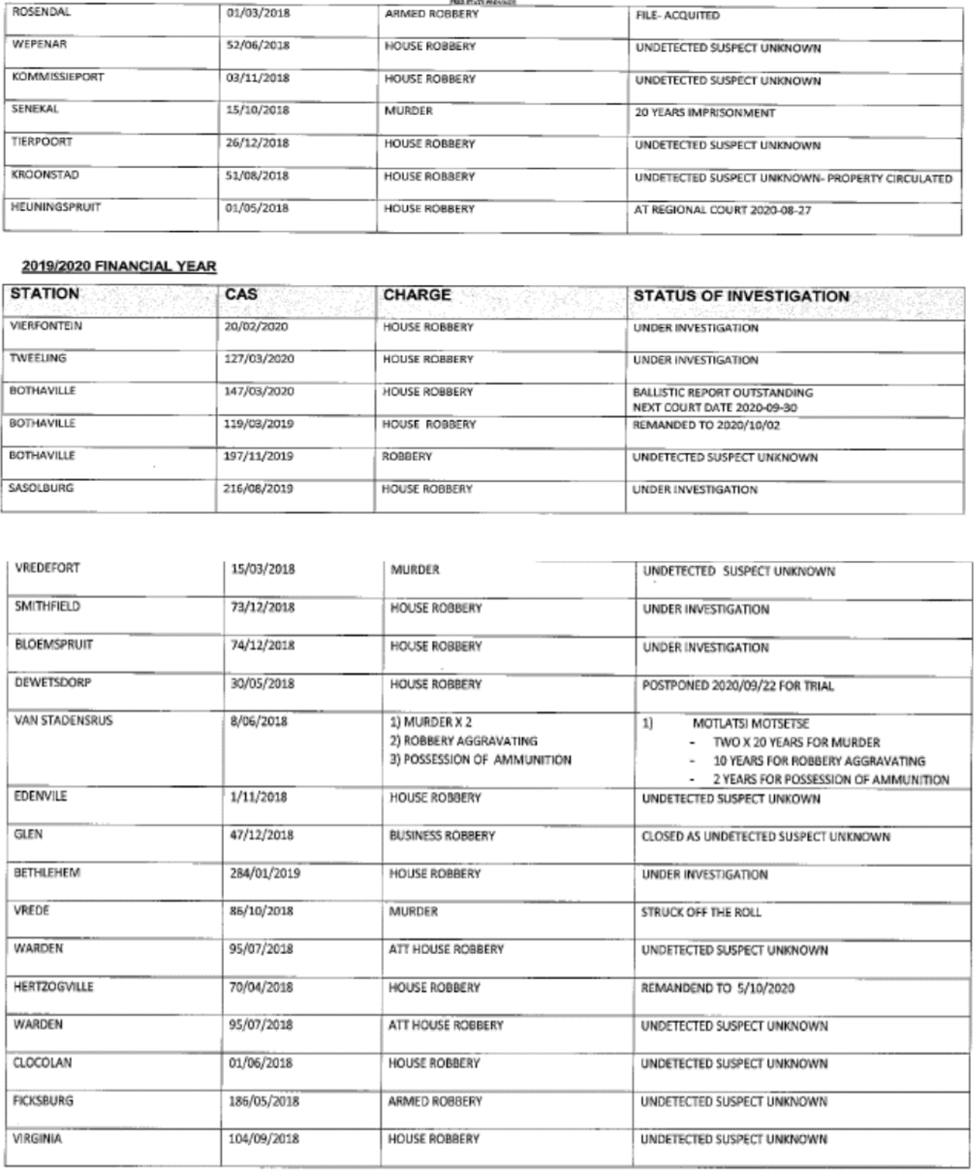

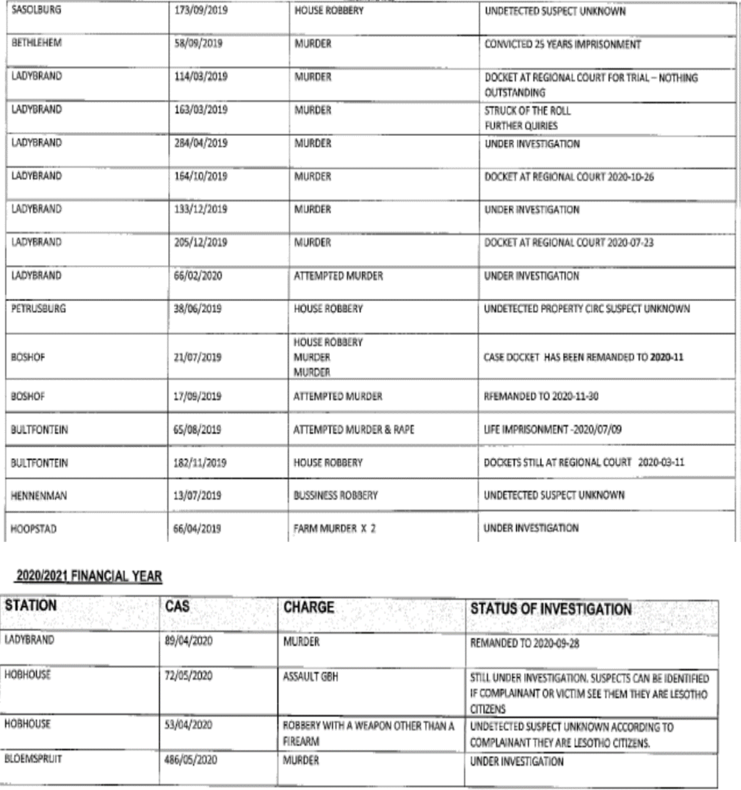

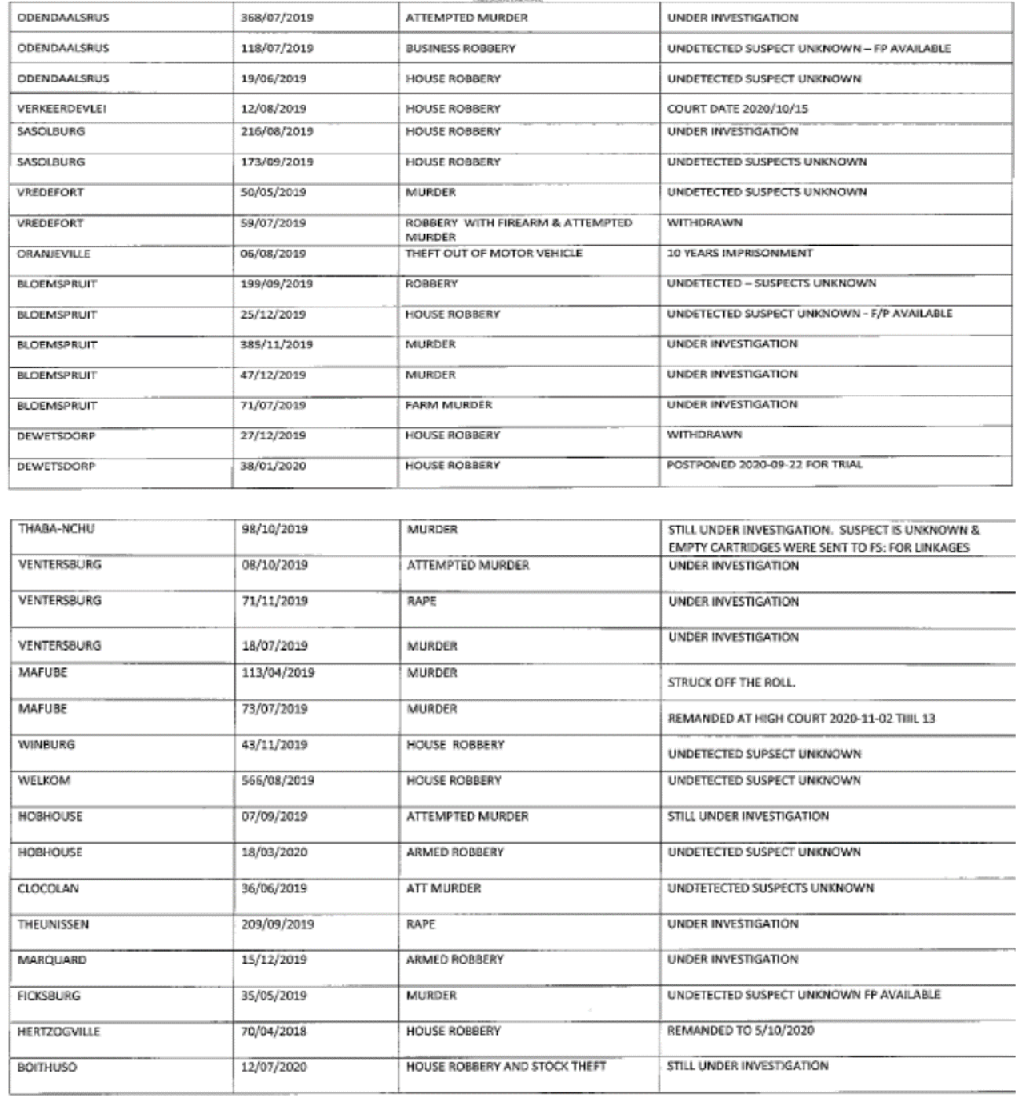

No.

Yes.

Particular hotspots include Navalsig police precinct especially the Riverside, Rodewal small holdings, small holdings in the Bloemspruit policing precinct, and farms in the Theunissen precinct. These station areas all reported 3 cases each.

The Harrismith and Hobhouse policing precincts reported 2 cases each.

Yes.

DAY |  | Total
MONDAY |  | 7
TUESDAY |  | 2
WEDNESDAY |  | 1
THURSDAY |  | 1
FRIDAY |  | 9
SATURDAY |  | 3
SUNDAY |  | 5
Grand Total |  | 28
TIME FRAME |  |  | Total
00:00 - 02:59 |  |  | 2
03:00 - 05:59 |  |  | 3
06:00 - 08:59 |  |  | 3
09:00 - 11:59 |  |  | 1
12:00 - 14:59 |  |  | 3
15:00 - 17:59 |  |  | 4
18:00 - 20:59 |  |  | 10
21:00 - 23:59 |  |  | 2
Grand Total |  |  | 28
TIME | MON |  | TUES | WEDNE | THURS | FRID | SATUR | SUN | Gran
FRAME | DAY |  | DAY | SDAY | DAY | AY | DAY | DAY | Total
00:00 | -
02:59 |  |  |  |  |  | 2 |  |  | 2
03:00 | -
05:59 |  |  |  |  |  | 2 | 1 |  | 3
06:00 | -
08:59 | 2 |  |  |  |  |  |  | 1 | 3
09:00 | -
11:59 | 1 |  |  |  |  |  |  |  | 1
12:00 | -
14:59 | 1 |  |  |  | 1 |  |  | 1 | 3
15:00 | -
17:59 |  |  |  |  |  | 1 | 1 | 2 | 4
18:00 | -
20:59 | 2 |  | 1 | 1 |  | 4 | 1 | 1 | 10
21:00 | -
23:59 | 1 |  | 1 |  |  |  |  |  | 2
Grand
Total | 7 |  | 2 | 1 | 1 | 9 | 3 | 5 | 28

Yes.

The Department with sister Departments co-operate with Free State Agriculture Union to develop and implement Rural Safety Strategies. These strategies are aimed at preventing, combatting and the investigation of all crimes in the rural areas, executing joint operations and exercises in case of attacks with the rural areas. In implementing the strategy, a Priority Committee has been established and it includes representatives of the Free State Agriculture Union. Bilateral engagements happens from time to time with stakeholders.

Over and above the Priority Committee, the Provincial Commissioner and her team met with Free State Agriculture Union representatives on 21 January 2020 and the Deputy Provincial Commissioner for Policing and his team had a bilateral meeting with representatives of the Free State Agriculture Union on 02 September 2020 reviewing safety strategies and crafting a way forward to ensure safety in the Rural Areas.

Joint awareness campaigns are conducted in the rural areas, as well as farm visits

47 vehicles have been dedicated for Rural Safety, it is necessary to indicate that Rural and Rural Urban mixed police stations vehicles are used to serve communities in those areas, there are no strict rules that specific vehicles should only be used in rural areas as this will compromise service delivery.

Yes.

South Africa has an extradition treaty with the Kingdom of Lesotho, the treaty allows perpetrators to be extradited to stand trial in South Africa. The Extradition is specifically provided for in the provisions of the Extradition Act, 1962 (Act No 67 of 1962) and the International Cooperation in Criminal Matters Act, 1996 (Act No 75 of 1996)

Yes.

The SAPS applies to Interpol for approval to conduct investigations in Lesotho and once approval is granted the investigation is conducted.

None. In most cases Stock Theft suspects are trialled in Lesotho and the outcome of the cases is then provided to the SAPS for the finalisation of the case dockets. There has been no extradition thus far.

