Alternative Budget 2021

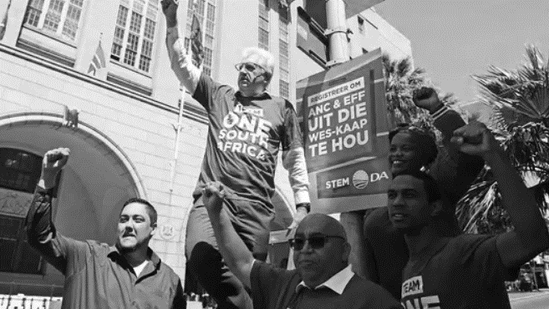
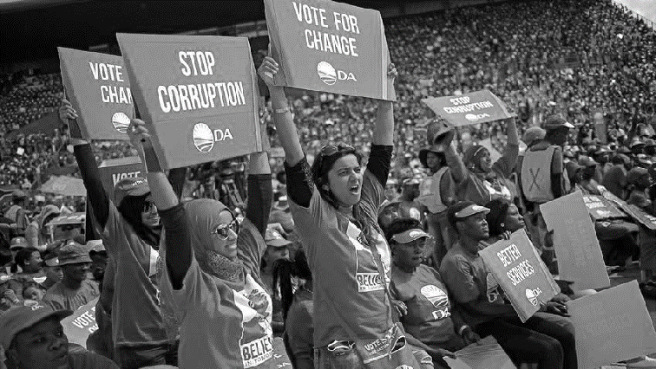

Contents
Contents
Introduction 1
New innovations: Debt and Growth projections 1
Key Message: 1
The DA’s debt and growth projections: 2
1. Debt and debt service costs: 2
2. The Growth Dividend 3
The DA’s core additional spending proposals: 4
1. Fully funded vaccine rollout programme: 4
2. Protect social spending: 5
3. Protect wages for frontline workers: 5
4. Budgeting for growth – protecting the public from loadshedding: 5
The DA’s core proposals for savings: 5
5. The public wage bill: 5
6. Post reduction of 9000: 6
7. Nominal freeze on other departments 6
8. Other: bailouts, NYDA, blue lights, wasteful expenditure: 6
Fiscal policy issues: 7
1. No new taxes: 7
2. No new bailouts: 7
The Spectator: The performance of the Minister 7
An Alternative Fiscal Framework That Protects 8

Figure 1: Debt-to-GDP projections – DA vs ANC 2
Figure 2: Debt service costs as a ratio to GDP – DA vs ANC 3
Figure 3: Debt service costs as a ratio to GDP - DA vs ANC 3
Figure 4: Government debt-to-GDP - The Growth Dividend – DA vs ANC 4

Table 1: 2020/21 MTEF presented during the MTBPS of 2020 8
Table 2: DA's Alternative Main Budget Framework 8

Introduction
The Democratic Alliance is pleased to present our Alternative Budget.
The DA’s Alternative Budget aims to provide a credible alternative fiscal path that would protect South Africa, through the funding of a large-scale vaccine rollout, whilst simultaneously protecting citizens from a sovereign debt crisis.
This will be no easy feat, and the DA does not pretend otherwise. The poverty and unemployment that follows economic stagnation will take grit and determination to turn around.
This Alternative Budget shows how a DA government would:
- Get South Africa’s crushing national debt under control, to stave off the looming debt crisis
- Protect essential social spending for the poor and most vulnerable
- Protect the wages of front line service delivery staff
- Avoid tax increases
- Fund a comprehensive vaccine rollout for everyone in South Africa
- Position South Africa’s economy for growth by funding a reform agenda
- Cut wasteful expenditure and bring down the public wage bill

Debt and Growth projections
The DA is also able to show modelling for how our proposals would get national debt under control sooner than government.
We also underscore the growth dividend, by showing how faster economic growth is the only way to solve South Africa’s fiscal crisis without impossibly steep spending cuts. The dividends of higher economic growth also mean that we could afford more social support and better basic services. The amount we spend on social support in a growing economy could end up being less if significantly more people are in employment. But the amount spent per person could increase, allowing us to provide better services for fewer people.

Key Message:
South Africa’s debt is unsustainably high, and our debt is too expensive. If we do not bring the price of our debt down, which is intrinsically linked to bringing the quantum of our debt down and growth reforms, then we will not be able to avoid a full-blown debt crisis.
Should this happen, and that likelihood increases with every budget target missed, the social consequences will be profoundly negative: wider impoverishment and deep cuts to social spending.
No one should want this to happen to South Africa.
And yet despite their own ever more dire warnings, the government continues to plunge deeper into debt, reneging on previous debt control commitments, while making no meaningful progress on the wide-ranging economic reforms necessary for economic growth.
Growth is the only way to pull South Africa out of the fiscal crisis it faces, without having to effect deep and painful spending cuts across the state.
Absent faster economic growth, government will be forced to choose which services can remain, and which will have to be discontinued altogether.
The DA has now decided to press ahead with this agenda for reform, by tabling every one of the most critical reform measures in Parliament, and by pressing ahead with this reform agenda where we are in government.
The DA is now the only party of government in South Africa that is committed to restoring fiscal discipline, for getting our national debt under control, and for protecting essential social services from strangulation by ever-rising debt costs.

The DA’s debt and growth projections:

Debt and debt service costs:
The DA is able to show how our spending cuts and savings, absent any adjustments in growth, would bring our national debt under control sooner, and at a lower rate, than the ANC government.
Figure 1 below models the spending proposals we make in this Alternative Budget. This is compared to the government’s debt forecasts, shown on the top line. We have used Treasury’s revenue forecasts and market consensus growth forecasts.
This shows that with very achievable spending cuts, and whilst still protecting essential social spending and frontline staff wages, the DA can turn debt around by 2024/25 and at 2.5 percentage points lower than the ANC. It is important to stress that these projections are without any changes to growth assumptions. And it is clearly not enough, therefore the importance of cuts alongside growth enhancing reforms is illustrated in Section 2, the Growth Dividend.

Figure 1: Debt-to-GDP projections – DA vs ANC
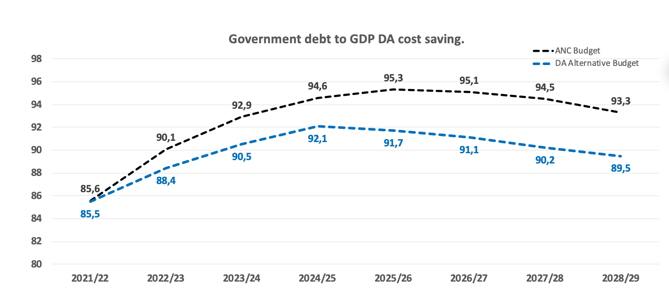

Figure 2 shows how the DA’s success in restoring debt sustainability sooner, pays dividends in lower service costs.
By 2024/25, our model implies a saving of R10,5 billion in debt service costs compared to the government.
Figure 3 depicts the same data.
Figure 2: Debt service costs as a ratio to GDP – DA vs ANC
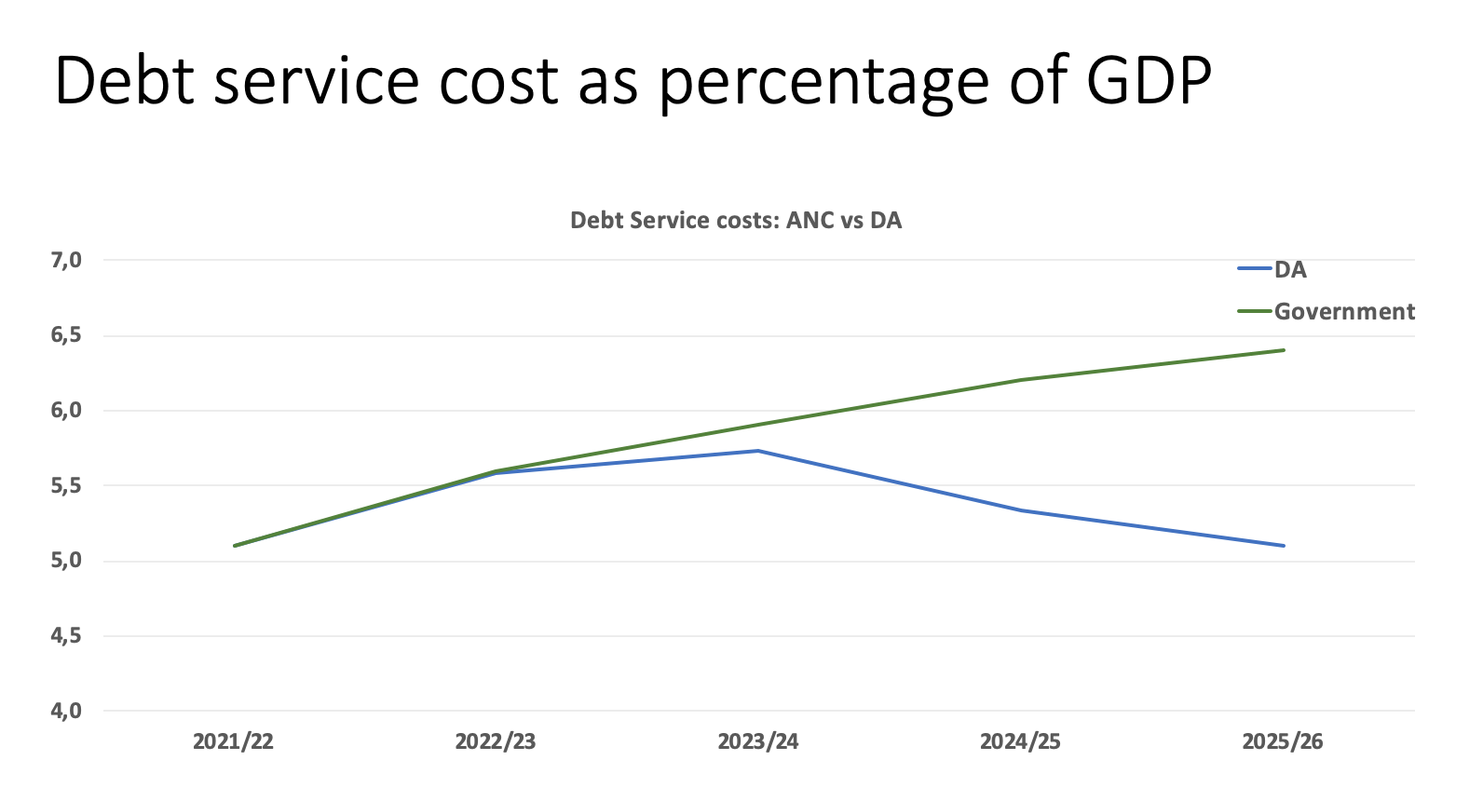

Figure 3: Debt service costs as a ratio to GDP - DA vs ANC
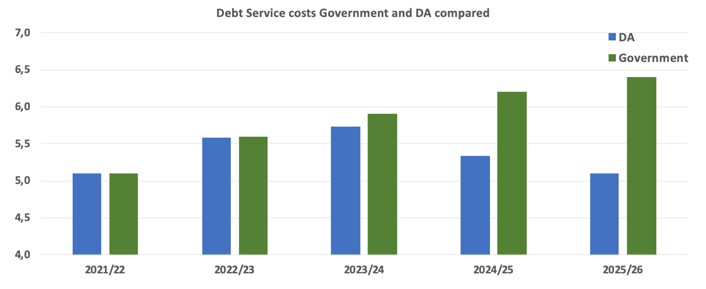

The Growth Dividend
With a faster-growing economy, many of the crises in South Africa would be alleviated. Two positive dividends from growth are worth emphasising again:
- Unemployment would start to tick down as new investment creates new jobs.
- As investment begins to flow in, and more people get into work, tax revenues go up without any increase in tax rates. This means government would have more revenue to spend on caring for the most vulnerable without demanding a larger slice of the economic pie.
South Africa can roll back poverty, can provide much greater support for the unemployed, and can invest in new infrastructure and smart cities. It can do all of this and more if, and only if, it reaps the dividend of sustained higher economic growth. The converse is also true. So long as the economy stagnates, South Africa will not be able to afford these things.
That is why making meaningful progress on a programme of wide-ranging economic reforms is so essential to position the economy for growth.
In Figure 4 we show how achieving economic growth of just 1.5 percentage points above the current average growth rate, resolves the national debt crisis.
This is why the DA is obsessed with achieving higher economic growth, and why the government’s inability to achieve reform is so disappointing.
The DA is now leading the growth and reform agenda.
We will table key economic reforms in Parliament, and where we govern, we will drive local reforms.
Figure 4: Government debt-to-GDP - The Growth Dividend – DA vs ANC
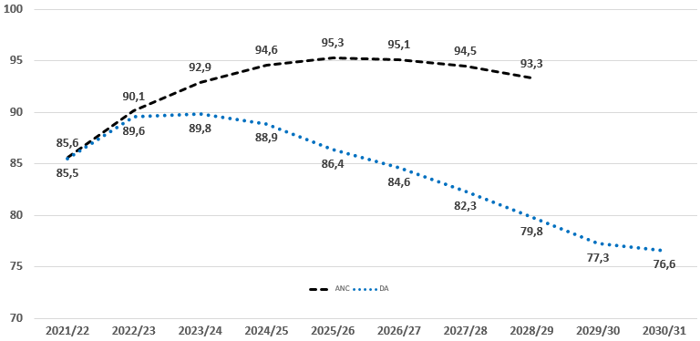

The DA’s core additional spending proposals:

Fully funded vaccine rollout programme:
The top new spending priority for the National Treasury should be the funding of a comprehensive nationwide vaccine rollout.
Current estimates put the total costs of a rollout at roughly R20.6 billion to vaccinate 67% of the populace, notwithstanding differences between estimates. To vaccinate the entire population is estimated to cost around R30 billion.
These estimates are based on the following distribution of vaccine options:
- 5% Moderna @ R536/dose (2-dose regimen)
- 5% Pfizer @ R299/dose (2-dose regimen)
- 70% AstraZeneca @ R54/dose (2-dose regimen)
- 20% Johnson & Johnson @ R153/dose (single-dose regimen)
- R277 maximum logistics cost per dose
Considering the low efficacy of the AstraZeneca vaccine on the new variant, a revised estimate increases costs by about 5% to R31.5 billion if it’s assumed that the AstraZeneca and Johnson & Johnson distribution percentages are simply switched out.
We budget fully for this cost: R35 billion.
It would be unacceptable for the Minister to present anything less than full funding for the vaccine rollout. This would render the budget a failure.
This is both the morally right thing to do, and is the first duty of the government. But it also an economic ‘no brainer’, as the cost of a comprehensive vaccine rollout is still a fraction of the economic losses associated with not vaccinating everyone.

Protect social spending:
The poor and most vulnerable should not pay the price for years of bad government and profligacy. Government spending on direct cash support for the poor should be protected from cuts at all costs. Indeed, we should be looking for ways to increase direct cash support for the poor, rather than cutting it. We are committed to protecting inflationary increases in social grants, health, and education.
We budget for social grant increases of R30,1 billion over three years.
Our projections assume the same number of grants is distributed, there would be fewer social grant recipients were the economy growing faster. Thus overall spending on grants over time would not necessarily be greater, but more meaningful per person.

Protect wages for frontline workers:
While we have written extensively about the need to lower the public wage bill, this burden should not fall on frontline service delivery staff – mainly nurses, teachers, and police officers. Workers at the lower end of the salary scale are less able to shoulder wage freezes.
We budget for inflationary increases for all frontline staff, defined as occupation specific dispensation staff (see discussion and figures below).

Budgeting for growth – protecting the public from loadshedding:
We cannot hope to grow our economy so long as it is strangled by loadshedding.
Eskom will not stop loadshedding in the medium term, and so we must find a way to make the economy less dependent on Eskom power.
Where the DA governs, we will pursue buying independent power to end loadshedding.
To support this, we propose that National Treasury establish a Cities Support Team to help cities procure independent power responsibly.
We budget R250 million for this support.
We also budget R4 billion over the period for our Emergency Solar Power Rebate, which provides a R75 000 tax rebate for solar power installation in homes and businesses. This rebate would save 480 mega-watts in electricity at an assumed uptake of 100 000 rebates over 4 years.

The DA’s core proposals for savings:

The public wage bill:
The DA proposes to cut the wage bill by:
• Freezing the wages of public servants not covered by the Occupation Specific Dispensation (OSD) (including the likes of head-office managers and supervisors) over the three-year MTEF period. This would yield savings of R116.7 billion;
• Ensuring that the 66.3% of public servants covered by OSD receive inflation-linked increases over the MTEF period. In order to achieve this and stay within the deficit target, the government needs to mobilize an additional R9.55 billion. This can be achieved by reducing the number of managers at non-OSD salary levels 11 to 16.

Post reduction of 9000:
In addition to the R116.7 billion that would be saved by freezing non-OSD salaries, the government can save another R29.4 billion over the MTEF period by reducing the number of ‘millionaire managers’ in the civil service. There is substantial evidence that head office managers in the civil service are significantly overpaid compared to similar positions in the private sector. These ‘millionaire managers’ are often not involved in direct service delivery related roles.
This saving would entail net retrenchments until the number of posts is reduced by a third – approximately 9 000 posts. Some of these posts are already vacant, and so actual headcount reduction would be lower.

Nominal freeze on other departments
Spending increases should be focused on protection for the most poor and vulnerable. And if debt is to be brought under control, departments which do not deliver core services on which the public rely, will need to have their budgets maintained at current nominal levels throughout the MTEF.
For this reason the DA suggests that, with the exceptions already mentioned, all departmental budgets are kept frozen at the nominal amounts appropriated as of the 2020 MTBPS.
This shows that, without any nominal spending cuts, and by freezing nominal allocations at the October 2020 limits, government can and should save the country from heading over a fiscal cliff.
We appreciate that this is not easy. But it is infinitely easier than what will come if South Africa is allowed to descend into full-blown debt crisis. The government must make the difficult choices now, and we believe the only justifiable choice to make is to protect services to the poor while focussing cuts on the rest of government.

Other: bailouts, NYDA, blue lights, wasteful expenditure:
We propose to save an additional R33.3 billion over the MTEF.
- R13.5 billion saved by cutting the New Development Bank funding by R4.5 billion each year
- R4.2 billion in fruitless and wasteful expenditure
- R3.4 billion slashing VIP blue light security
- R8 billion from digital spectrum auction
- R1 billion shutting down the NYDA
- R3 billion clawed back by providing no further working capital for SAA

Fiscal policy issues:
Beyond considerations of saving and new spending, we make the following remarks on fiscal policy issues.

No new taxes:
We expect that the Minister may introduce new taxes of between R5 and R10 billion, which would be consistent with his indications in the October 2020 mid-term budget. This would be a mistake.

South African families and businesses have gone through a terrible year, and face enormous stress and strain. They cannot afford any more taxes.

We oppose any new taxes, and are very firmly opposed to any income tax increases (including by stealth by failing to adjust brackets for inflation) or petrol tax increases. VAT increases are not on the cards.

We cannot tax South Africa’s economy back to growth. Government’s fiscal multipliers are well below 1, which is simply to say that government takes more value out of the economy than it puts in.

No new bailouts:
On top of the R56 billion bailout for Eskom that is already allocated, we expect yet more bailouts for SAA and quite possibly more for Eskom as well, along with a figure between R5 billion and R10 billion for the Land Bank.
These bailouts all come at the cost of either direct cuts now to basic service delivery, or higher debt now, and therefore even deeper cuts to basic services later. We do not believe these bailouts to be morally justifiable given the need in South Africa, and we oppose them strongly.

The Spectator: The performance of the Minister
Tito Mboweni has increasingly become a ‘Spectator Minister’ – he speaks as though he is watching events from the outside, rather than a key player with the power to change events himself. He frequently lectures to the country about the dangers of our debt situation, as if it is the country, and not he who delivers the Budget.
He has reneged on his ‘active scenario’ debt control plan, reneged on his ‘no bailouts’ promise, and has left the government’s key reform strategy, “Operation Vulindlela”, to his Deputy Minister.
In June 2020, in his Emergency Budget, Mboweni committed the government to an ‘active approach’ to stop the debt spiral, saying:
“Cabinet, under the leadership and guidance of the President, has found the narrow gate. Government shall go through it.
Government will narrow the deficit and stabilise debt at 87.4 percent of GDP in 2023/24. Cabinet has also adopted a target of a primary surplus by 2023/24.”
But just months later, in his October mid-term budget, Mboweni rowed back from this commitment, and extended the target date for debt stabilisation out to 2026.
One result of the Minister’s disengaged ‘spectator’ attitude, is that the National Treasury is increasingly side-lined in government decision making, and is a weakened institution. For example, critical vacancies at the Treasury now stand at 11%, indicating a flight of skilled employees. To be sure, the National Treasury remains an island of relative excellence, but diminishingly so.

An Alternative Fiscal Framework That Protects
In October 2020, National Treasury projected a main budget framework as follows:
Table 1: 2020/21 MTEF presented during the MTBPS of 2020
 | 2020/21 | 2021/22 | 2022/23 | 2023/24
Main budget revenue | R 1 097 900 000 | R 1 263 600 000 | R 1 388 300 000 | R 1 487 100 000
Main budget expenditure | R 1 805 800 000 | R 1 801 100 000 | R 1 874 800 000 | R 1 924 600 000
Non-interest expenditure | R 1 572 700 000 | R 1 529 300 000 | R 1 557 200 000 | R 1 571 500 000
Debt-service costs | R 233 000 000 | R 271 800 000 | R 317 600 000 | R 353 100 000
Main budget balance | -R 707 800 000 | -R 537 400 000 | -R 486 600 000 | -R 437 500 000
Primary balance | -R 474 800 000 | -R 265 700 000 | -R 169 000 000 | -R 84 400 000
Nominal GDP growth | -5,60% | 9,40% | 5,90% | 5,90%
Tax buoyancy | 3,18 | 1,59 | 1,5 | 1,35

Accounting for the DA’s changes, our Alternative Fiscal Framework emerges as follows:
Crucially, this demonstrates that by implementing these changes to expenditure, government can go from a forecasted primary balance deficit this year of R474,8 billion, to a primary balance surplus of R4.3 billion by 2023/24.

Table 2: DA's Alternative Main Budget Framework
Alternative Main Budget Framework
 | 2020/21 | 2021/22 | 2022/23 | 2023/24
Main budget revenue | R 1 159 900 000 000,00 | R 1 263 600 000 000,00 | R 1 388 300 000 000,00 | R 1 487 100 000 000,00
Main budget expenditure | R 1 805 800 000 000,00 | R 1 813 790 928 946,67 | R 1 782 081 982 480,93 | R 1 811 777 388 630,39
Non-interest expenditure | R 1 572 700 000 000,00 | R 1 541 990 928 946,67 | R 1 464 481 982 480,93 | R 1 458 677 388 630,39
Debt-service costs | R 233 000 000 000,00 | R 271 800 000 000,00 | R 317 600 000 000,00 | R 353 100 000 000,00
Main budget balance | -R 645 900 000 000,00 | -R 550 190 928 946,67 | -R 393 781 982 480,93 | -R 324 677 388 630,39
Primary balance | -R 412 800 000 000,00 | -R 278 390 928 946,67 | -R 76 181 982 480,93 | R 28 422 611 369,61
Nominal GDP | R 5 132 300 884 955,75 | R 5 309 243 697 478,99 | R 5 620 647 773 279,35 | R 5 972 289 156 626,51
Primary balance/GDP | 8,04% | 5,24% | 1,36% | 0,48%
Main budget balance/GDP | 12,58% | 10,36% | 7,01% | 5,44%
 |  | 2021/22 changes | 2022/23 changes | 2023/24 changes
Net cut |  | -R 30 709 071 053,33 | -R 77 508 946 465,73 | -R 5 804 593 850,54
Social grants inflation-linked increase |  | R 8 824 262 280,00 | R 10 324 386 867,60 | R 11 028 739 482,79
Freezing of non-OSD wages |  | -R 45 700 000 000,00 | -R 71 000 000 000,00 | R -
Other wage cuts (R29.4 billion over MTEF) |  | -R 9 800 000 000,00 | -R 9 800 000 000,00 | -R 9 800 000 000,00
Cut New Development Bank |  | -R 4 500 000 000,00 | -R 4 500 000 000,00 | -R 4 500 000 000,00
Fruitless and wasteful expenditure |  | -R 1 400 000 000,00 | -R 1 400 000 000,00 | -R 1 400 000 000,00
Slashing VIP blue light security |  | -R 1 133 333 333,33 | -R 1 133 333 333,33 | -R 1 133 333 333,33
Auctioning off digital spectrum |  | -R 8 000 000 000,00 | R - | R -
Shutting down NYDA |  | -R 1 000 000 000,00
Providing no further capital to SAA |  | -R 3 000 000 000,00
Vaccine rollout funding |  | R 35 000 000 000,00 | R - | R -

Numbers adjusted for inflation-linked increases in wages for frontline workers
Department of Health. 2021. COVID-19 Response. https://businesstech.co.za/news/government/459488/south-africas-covid-19-vaccine-rollout-plan-who-gets-it-what-it-costs-and-how-government-says-it-will-work/
DA Medium Term Budget Policy Statement 2019: Preview Document.
Ibid.
Ibid.
National Treasury. 2020. Supplementary Budget Review. http://www.treasury.gov.za/documents/national%20budget/2020S/review/FullSBR.pdf
National Treasury. 2020. Medium Term Budget Policy Statement 2020. http://www.treasury.gov.za/documents/mtbps/2020/mtbps/FullMTBPS.pdf?fbclid=IwAR21nTm_wfVEgoxwU-5QhJhDn5O2lLSRawwD24oJPnZcgOCLdc8vzgpKI_I
Ibid.

