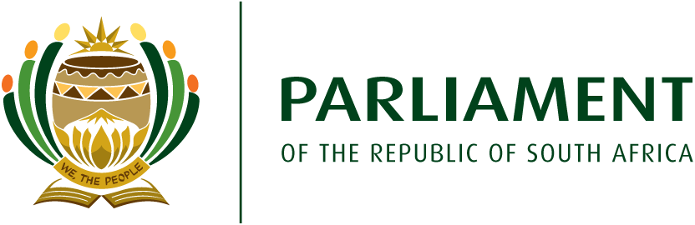
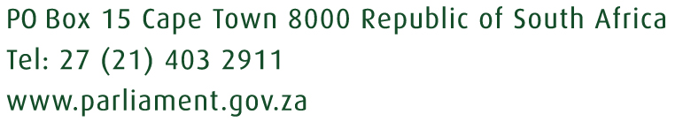

24/03/2021

Dear Minister

Re: Request for urgent independent forensic investigation - NAC
The Democratic Alliance (DA) hereby request that you urgently institute an independent forensic investigation into the National Art Council’s (NAC), after an article in the Daily Sun (https://www.dailysun.co.za/Celebs/shock-over-chomees-millions-20210324) which makes shocking allegations.

South Africa needs to get answers:

- Thulisile Madihlaba, or Chomee`s company, Divatainment – how did it receive R2 million when the Companies Intellectual Property Commission record apparently shows that the company is in deregistration?
- Her NAC proposal said that the funds were meant for a project called Online Broadcasting Development Programme, but the project never saw the light of day.
- Did companies directly or indirectly linked to Arthur Mafokate receive funding? If, on what basis?
- How did it happen that Mafokate and his family receive R10 million from the NAC, according to this article?
- On what merits was his record label, 999-Music, approved for R1 million?
- And Roadshow, also his company, apparently was approved for R2 million?
- Queendom, his daughter`s company, was apparently approved for R719 070.00.
- Black Technical Production Association, owned by Mafokate's son, Lesego, was apparently approved for R849810. He also received R20 000.
- SAADA, a company where Mafokate is chairperson, along with his two sisters and Chomee, was apparently approved for R1.9 million, according to this article.
- The article states that not only was the money approved, but also allocated.

Minister, I think that you would agree that this along with all the other concerns previously linked to the NAC, calls for a serious independent forensic investigation into the NAC. I previously asked that the National Arts Council should be investigated, I ask you again. There is no more time for excuses.

The Committee will be on our oversight visit at the NAC on Wednesday, 7 April 2021. I hope Minister that you too, will also be there to provide feedback to the artists in our presence.

Please seriously consider this request as a matter of urgency.
Kind Regards
Veronica van Dyk MP
Deputy Shadow Minister of Sports, Arts & Culture
Head Kamiesberg and Khaima Constituency
Democratic Alliance
Parliament of South Africa
PO Box 15
Cape Town
8000
(phone: 083 2362152)

