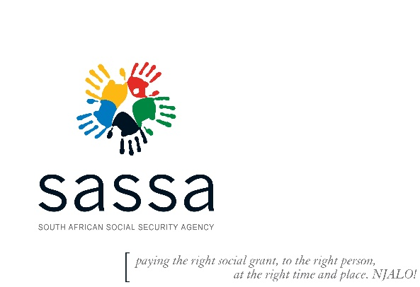ENQUIRIES : Mr. Clive Jansen

TEL : 021 469 0205

E-MAIL : AbrahamM@sassa.gov.za

EMAIL TO: [alabrahams@parliament.gov.za](mailto:alabrahams@parliament.gov.za)

**HON. ALEXANDER ABRAHAMS**

MEMBER OF PARLIAMENT OF RSA

PORTFOLIO: SOCIAL DEVELOPMENT

Dear Honourable Ms Abrahams

**VYGIESKRAAL INFORMAL SETTLEMENT RESIDENTS - UPDATED CELL NUMBERS**

1. Receipt of your email 23 September 2021 with regard to the outstanding SRD payments of the Vygieskraal informal settlement has reference.

2. **BACKGROUND**

2.1 SASSA Western Cape has always provided SRD assistance as prescribed by the regulations during disasters and or when citizens experienced undue hardships. The relief measures have included hot meals and cash payments through the Post office and recently into the bank accounts of the affected clients.

2.2 SASSA utilized the South African Post Office (SAPO) as the cash payment service provider for once off cash payments but increasing queues at the Post Office led to SASSA developing a system to pay these relief benefits through clients’ banks accounts. The first and second batches of clients were paid through the Post Office but the last group of about 62 clients will be paid through their bank accounts.

**3. SASSA DELAYS IN PAYING THE LAST GROUP OF CLIENTS**

3.1 This process was delayed due to Covid-19 impact on staff and our offices including mobile offices that had to be closed according to lockdown level 3 protocols. Also, these were delayed due to changes that happened with regard to payment channel as explained above, i.e. that they had to receive their money via their bank accounts. This was communicated to the clients that they will not be paid through SAPAO like the previous group. It took a while for these clients to provide their banking details while others were quite difficult to trace as their contact details had changed or were not reachable on the numbers that were on the list. With the assistance of local community leaders including MP Abrahams, SASSA was however able to finally get the required contact details and eventually their banking details.

3.2 While this group was still being contacted, the amount of the SRD was reduced to R700.00. In the interest of fairness, a separate motivation had to be made that these clients be paid the original R1780.00 amount like the previous groups.

3.3 SASSA can now confirm that all the 62 beneficiaries’ outstanding banking details have been received. These have been uploaded in to the system for payment from the second week of October, immediately after the scheduled grants payment cycle.

3.4 I would like to apologise for the delays and would like to assure you that similar delays should not happen again in the future.

Hope you will find the response in order.



_________________________________



**MR. A MAHLANGU**



**ACTING REGIONAL EXECUTIVE MANAGER: SASSA WESTERN CAPE**



**Date:**



Cc: Ms TBJ Memela-Khambula-CEO SASSA

Mr Abram Phahlamohlaka- Chief of Staff (Office of the Minister of Social Development)