QUESTIONS FOR WRITTEN REPLY
NAME OF MEMBER PUTTING THE QUESTIONS: Hon. B. Singh (DA)
QUESTION ADDRESSED TO: MEC for Arts and Culture
QUESTION;
For Written Response
MEC: Arts and Culture
RE: IRREGULAR EXPENDITURE OVER INTERNET CONNECTIVITY
Parliamentary questions:
1. How much was paid to Telkom for internet connectivity in the last financial year?
2. What was the value of the 3 year tender for internet?
3. In the Departments AFS an amount of R9.159 million was disclosed as Irregular expenditure which was paid to Telkom in respect of an expired contract. Please could this be explained?
4. Who is being held accountable for this Irregular expenditure?
5. In the AFS R1.487 million was disclosed as Fruitless and Wasteful expenditure for the possible duplication of internet cost. Please could an explanation be provided.
6. Who will be held accountable for the Fruitless and Wasteful expenditure incurred?

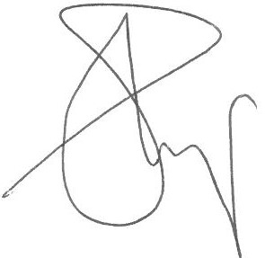

HON B SINGH
Signature of member giving question
Date: 30 November 2021

