Making Parliament Work For The People

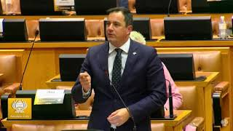

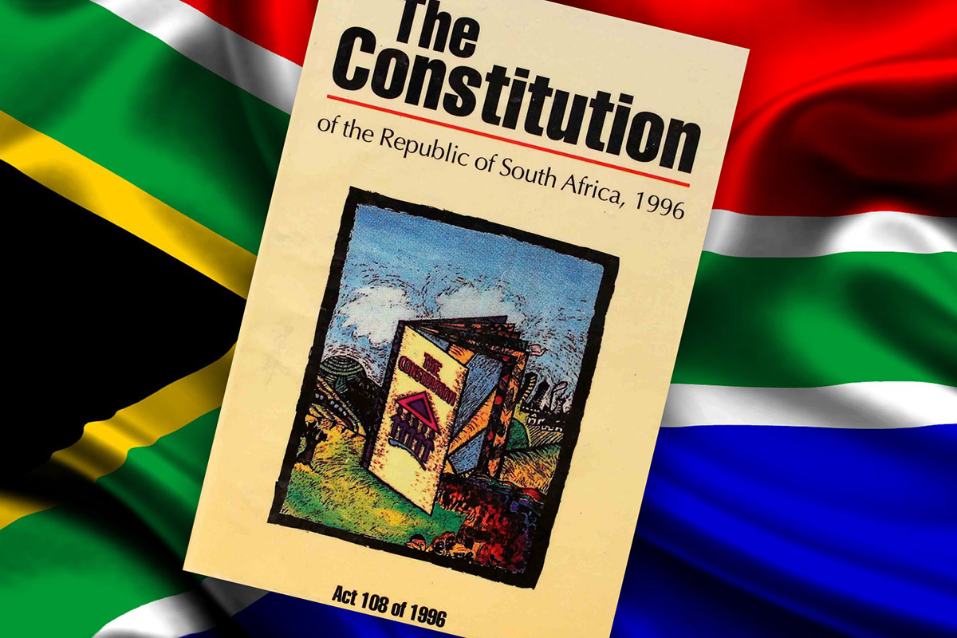
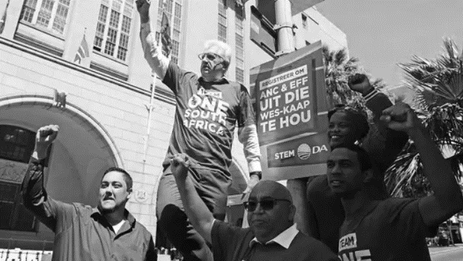
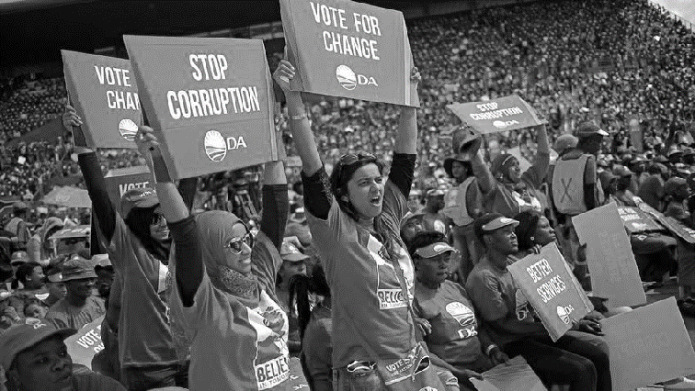

CONTENTS:

Introduction 2

A Committee to Oversee the Presidency 5

Increasing the Accountability of the Speaker 5

Increasing Opposition Chairperson Representation and Systems 6

Fixing Parliamentary Oversight 8

Enhancing Parliamentary Protection Services 9

Increasing the Frequency of Presidential Questions 10

Creating Penalties for Cabinet Non-Attendance 11

The Reintroduction of Interpellations 12

Creating Penalties for Failing to Answer PQs Timeously 12

Ensuring Parliament Takes Action on the Zondo Report 13

Introduction:
Today the Official Opposition Democratic Alliance (DA) is announcing a host of actions which will seek to bolster the central role of Parliament in our democracy. The DA has, for many years, highlighted the failure of Parliament to hold the executive to account. There is an urgent need for parliamentary oversight to be strengthened, and the independence of Parliament enhanced.
The DA has a plan to get this done.
The DA provided extensive testimony at the State Capture Commission concerning how Parliament failed to take its oversight role seriously during the state capture years. In the recently released State Capture Reports, it was confirmed that Parliament systematically failed to perform its role of holding the executive to account. Chief Justice Raymond Zondo stated that:
“[Parliament] failed to use the oversight and accountability measures at its disposal”

Parliament has continuously acted as a lapdog of the executive, merely rubber-stamping decisions brought before it. Parliament has also failed dismally in performing its central oversight role over the executive, with ANC MPs actively preventing members of the executive from being interrogated and held accountable for their behavior and decisions.
This stems from the ANC’s policy of ‘cadre deployment’, where MPs are seen as being deployed to Parliament or the executive to simply do the bidding of the party.
This continues today, when the Speaker of the National Assembly refused the DA’s request to establish an ad-hoc committee to investigate allegations surrounding the theft and alleged cover-up at President Ramaphosa’s Phala Phala farm. This demonstrates the continued shielding of the executive by Parliament, contrary to the accountability role Parliament is tasked to play by our Constitution.
The requirement that Parliament serves as a mechanism to enforce accountability and perform oversight over the executive is outlined within our Constitution.
- The founding values of South Africa includes in Section 1(d) of the Constitution, “Accountability, Responsiveness and Openness”.

- Section 42(3) of the Constitution provides that:
“The National Assembly is elected to represent the people and to ensure government by the people under the Constitution. It does this by choosing the President, by providing a national forum for public consideration of issues, by passing legislation and by scrutinizing and overseeing executive action”
- Section 55(2) of the Constitution further provides that:
“The national assembly must provide for mechanisms-
(a) to ensure that all executive organs of state in the national sphere of government are accountable it; and
(b) to maintain oversight of (i) the exercise of national executive authority, including the implementation of legislation; and (ii) any organ of state”

As constitutionalism is a core value of the DA, the party will seek to embrace, further and defend all aspects of the Constitution. It is essential that Parliament functions properly – our democracy depends on it.
This requires that the principle of separation of powers be strengthened in respect of Parliament in particular. Under the doctrine of separation of powers, Parliament should operate independently of the other two branches of government – the executive and the judiciary.
While DA has played an instrumental role in promoting a culture of accountability, there is a need for structural parliamentary reforms to ensure the institution can perform effective oversight and operate more independently of the executive in the future.
Given these values, the DA will seek to:
- Ensure that Parliament operates independently of the other branches of government, and the executive in particular.

- Ensure that Parliament has the capability to exercise its oversight responsibilities effectively.

The following actions and recommendations are presented by the DA to improve separation of powers within Parliament, and ensure greater parliamentary oversight over the executive:

- Establishing a committee to oversee the Presidency.

- Increasing the accountability of the Speaker to ordinary members of Parliament.

- Increasing representation of opposition committee chairpersons.

- Fixing parliamentary oversight and ensuring meaningful public participation.

- The enhancement of the Parliamentary Protection Services through legislative amendments.

- Increasing the frequency of Presidential oral question sessions.
- Creating penalties for cabinet members who fail to appear for meetings or answer oral questions adequately.

- The reintroduction of interpellations.

- The introduction of punitive measures relating to unanswered, late or inadequate parliamentary question answers.

10) Ensuring that Parliament processes and takes timely action on the State Capture Reports.

To ensure these actions the DA will:

- Submit a proposal to the Rules Committee – to call for the establishment of a Portfolio Committee to conduct oversight over the Presidency throughout the Parliamentary term, and on Vote 1: The Presidency.

- Introduce new rules into the National Assembly which will make the Speaker accountable to Parliament.

- Seek to amend Rule 158 to ensure greater representation of Chairpersons from different parties and improving Committee procedures.

- Introduce legislation to govern oversight, what is allowed and how these activities may be carried out – The Oversight PMB.

- Enhance Parliamentary Protection Services as the official protection service for Parliament and implement stronger controls over the actions of the police when on the parliamentary precinct.

- Amend the rules to require that the president answer questions at least once a month, thereby solidifying the central role that Parliament plays within our democratic system.

- Amend the Rules to outline pre-set repercussions for a Minister who fails to attend a pre-determined number of question sessions or fails to attend a committee meeting without adequate cause.

- Request that the Rules Committee reintroduce the interpellation mini debate form into the rules of the National Assembly.

9. Establish firm punitive measures for Ministers who do not answer written questions in time, with adequate detail, or failing to respond at all.
10. Petition for the establishment of an ad hoc committee that will monitor and implement the findings of the State Capture Reports.

- Establishing a committee to oversee the Presidency

The Issue
There is currently no effective and regular oversight mechanism over the acts and omissions of the President and the Presidency. This has resulted in inadequate levels of oversight and accountability exercised by Parliament over the Presidency.
“It is recommended that Parliament should consider whether it would be desirable for it to establish a committee whose function is, or includes, oversight over acts or omissions by the President and Presidency, which are not overseen by existing portfolio committees.”
Zondo has recommended that a Parliamentary Committee be established with the function of conducting oversight over the acts and omissions of the President and the Presidency.

In addition, the Budget Vote 1 for the Presidency is currently the only budget vote without any form of parliamentary oversight. Given that the President has now centralised so many functions of his office, the need for an oversight committee over this vote is increasingly of critical importance.
How the DA is getting things done:
To further strengthen parliamentary oversight, the DA under rule 225 of the National Assembly, will submit a proposal to the Speaker in concurrence with the Rules Committee– to call for the establishment of a Portfolio Committee to conduct oversight over the Presidency throughout the parliamentary term, and on Vote 1: The Presidency in particular.

- Increasing the accountability of the Speaker to ordinary members of Parliament

The Issue
There is currently no effective accountability mechanism to hold the Speaker to account from the perspective of ordinary Members of Parliament.

The Joint Standing Committee on Financial Management of Parliament and the National Assembly Programming Committee are currently the only forums where the Speaker may be held accountable by Parliament. However, this fails to provide a general opportunity for all members to ask questions relevant to the institution.

There is a need for the Speaker, at regular sessions of the National Assembly and chaired by the Deputy Speaker, to answer questions from members, on matters of institutional importance.

The need for an additional accountability mechanism has been made clear in the Speakers recent denial of the DA’s request to establish an ad-hoc committee to investigate the Phala Phala farm robbery. Were there to be regular question sessions with the Speaker, the DA would be able to interrogate the Speaker as to the specifics of why our request was denied.

How the DA is getting things done:

The Constitution

- Section 57(1)(a) and (b) of the Constitution empowers the NA to make its own rules and internal arrangements.

The Rules of the NA

• We will seek to change Section 26 of the Rules to add an additional responsibility of the Speaker to account before Parliament generally, and to answer questions from ordinary members in the National Assembly. Section 26(1)(c) in particular may be relevant as this section compels the Speaker to consult with relevant office bearers and structures within Parliament.

These amendments will enhance the principle of Parliament managing its own affairs, thereby increasing the institutions independence.

- Increasing representation of opposition committee chairpersons and regulating committee systems

The Issue
The effectiveness of a committee depends in large part on the quality of the presiding chairperson. Presently, almost all chairpersons are derived from the ANC, after being endorsed by their NEC, and on the recommendation of their Cadre Deployment Committee.

This process of determining a chairperson results in high levels of deference to party leadership within the committee system, thereby diminishing the ability of Parliament to effectively hold the executive to account.

Far too often, probing questions and interrogation into presentations made by the executive tends to always come from opposition MPs.

Highlighting this problem, Zondo stated that:
“Widely publicised allegations of state capture came to a head in early 2016, but the ANC was unwilling to support requests by opposition parties for a portfolio committee or an ad hoc committee to inquire into these allegations”.

Zondo further lamented that:
“Some of the practices that undermined oversight included that ministers frequently attended ANC study group meetings which precede portfolio committee meetings. There is evidence that a minister colluded in such a meeting to frustrate proper oversight by a portfolio committee.”

How the DA is getting things done:
There is a need for a greater number of committees being presided over by independent-minded chairpersons, reduce voting thresholds to call a person before the committee, and changing committee functioning to a system which allocates specified time allocations to parties during questioning periods.
The DA will seek to amend Rule 158 to require that a set number of committees be chaired by opposition MPs based on representation levels in Parliament. It may also be desirable to determine that committees with important oversight roles be mandatorily chaired by opposition MPs. These chairpersons would be better positioned to guide their committees in performing effective oversight and holding the executive to account. Details of these requests will be brought before the parliamentary Rules Committee.
To further enhance oversight within Parliament, the DA will request that the support of only 35/40% of members required to quorate a meeting be required to summon a person before it. This will prevent larger parties from impeding the committee’s ability to summon persons of interest before it.
The current committee system is also insufficiently regulated at present. Currently MPs are able to ask question, with limited recourse to ask follow up questions. It is also difficult for a MP to conduct a prolonged line of questioning during a committee session. The DA will therefore request within the Rules Committee that a questioning system which allocates a set time to each party based on representation levels. This time can then be used however a party wishes to ask questions and follow up questions in succession. It should also be permissible to cede time to another MP or party if desired. This question time should occupy a large proportion of the meeting, instead of what is currently far too often a tick-box exercise.

- Fixing Parliamentary Oversight and Ensuring Meaningful Public Participation

The Problem
There is currently inadequate resources allocated to the engine rooms of Parliament – the portfolio committees. Zondo highlighted that out of the total budget of R2 billion for Parliament, only R50-R60 million is allocated to cover the financial requirements of portfolio committees. This severely hampers the ability of Parliament to conduct effective oversight, perform regular oversight visits and ensure widespread meaningful public participation in the legislative process.
Far too often, budgetary constraints result in public participation being treated as a tick-box exercise within Parliament.
Furthermore, there is currently no legislation governing oversight visits of MPs. This leaves uncertainty pertaining to the circumstances under which oversight can be done, and what remedies are allowed should an oversight visit be denied. This has resulted in a legal lacuna, where it is unclear exactly what is permissible during an oversight visit.
How the DA is getting things done:
Currently oversight powers are governed by the Constitution in section 55(2) and 56. These provisions are overly broad and inadequate.
There is a need for clarity in the powers of oversight for parliamentary committees and individual members. There should be clear powers of entry over even sensitive installations of state, and at all times of day. Furthermore, powers must be expanded upon in relevant legislation relating to access to documents and requiring testimony from any persons. While some of these powers are referred to in the Constitution, it would be useful to clarify these powers and their boundaries within subsidiary legislation.
The DA will introduce legislation to govern oversight, what is allowed and how these activities may be carried out – The Oversight PMB. This Bill will expand upon the powers already granted within the Constitution by providing greater detail on what is permitted during oversight activities. This Bill will seek to provide clarity on the powers of oversight afforded to MPs and make explicit provision for unannounced oversight visits.

The DA will also advocate for a greater proportion of the Parliamentary budget to be allocated to Portfolio Commitees, so as to ensure that proper, frequent and effective oversight can be conducted, and meaningful public participation occurs.
- The enhancement of the Parliamentary Protection Services

The Issue
The Powers Privileges and Immunities of Parliament and Provincial Legislatures Act currently allows for members of the security services to enter and remain within the Parliamtary precinct for the purpose of performing any policing function after receiving permission and while remaining under the authority of the Speaker or Chairperson.
However, in situations where there is an immediate danger to the life or safety of any persons, or damage to any property, the police may enter the premise without this authority, but following their entry, must then report to the Speaker or Chairperson as soon as possible afterwards.
The presence of the SAPS within Parliament is problematic as the police service is controlled by the executive. Therefore, a risk exists of the executive using the police to control Parliamentary activities and infringe on the separation of powers.
This problem was highlighted in 2015, when President Zuma’s state of the nation address was marred in scandal. Firstly, a signal jamming device was used without the permission or knowledge of the Presiding Officers. Secondly, former president Zuma’s speech was continuously disrupted until a special unit of the SAPS was subsequently called in to remove the disrupting MPs. The DA successfully challenged the constitutionality of these actions, with the Constitutional Court declaring the actions of the SAPS to have constituted an impermissible limitation on a member’s freedom of speech.
How the DA is getting things done:
There is a need for a stronger independent Parliamentary Protection Services which should perform most of the security functions within the precinct. This would enhance the separation of powers between the executive and the legislature and ensure that the SAPS cannot be used by the executive to ‘bully’ Parliament.
The DA will ensure that:
- PPS is properly augmented, trained and equipped to guard the precinct and guarantee the safety of MPs, with a direct line of accountability to the Speaker and Chairperson.

- SAPS serve only in an auxiliary role on the parliamentary precinct, and under the direction of PPS at all times. This will sever the relationship between SAPS and the executive when operating on parliamentary grounds.

- A joint standing committee of Parliament be established to oversee and direct this augmented PPS service.

- Officials in command of PPS be authorised and equipped to receive intelligence relating to security of the precinct and the safety of ordinary members.

- SAPS must fall under the direction of PPS when they are within the parliamentary precinct.

- PPS must be responsible for the personal protection of officers of Parliament.

- Security of cabinet members shall remain the responsibility of VIP Protection Services, but these officers must be under the direction of PPS when they are within the parliamentary precinct.

The legislative steps we will take
- The DA will seek to amend Section 4 of the Powers, Privileges and Immunities of Parliament and Provincial Legislatures Act 2004. Stronger requirements and controls over the actions of the police will be added to this legislative section.

- Further legislative and Rules amendments may be sought to make the Parliamentary Protection Services (PPS) an enhanced official protection service within the parliamentary precinct.

- Finally, concurrent supplementary amendments within the National Key Points Act and the SAPS Act will be sought where appropriate.

- Increasing the frequency of Presidential oral question sessions.

The Issue
The President currently provides Parliament with oral replies to questions at least once per quarter. This level of frequency leaves large gaps between question sessions, which weakens the accountability Parliament exercises over the President.
In the UK parliamentary system, the Prime Minister must answer questions in Parliament every Wednesday. It is therefore clear that South Africa’s once per quarter convention is simply inadequate.
Even this quarterly oral question session was avoided by the President and the ANC, when the President failed to respond to oral questions during the second term of Parliament 2022, instead opting to only answer questions during the debate on Budget Vote 1: The Presidency.
How the DA is getting things done:
- The DA will seek to increase the level of regularity that the President is required to answer questions within Parliament. The DA will request that the president answer questions at least once a month, thereby solidifying the central role that Parliament plays within our democratic system.

- We will seek to change Rule 140(1)(a) in the Rules Committee to require that presidential question sessions must be scheduled at least once per month.

- Creating penalties for cabinet members who fail to appear for meetings or answer oral questions adequately.

The Issue
Far too often, members of the executive fail to appear for parliamentary meetings on time or at all – with belatedly tendered excuses offered.
It has also become an increasing occurrence for members of cabinet to fail to adequately answer oral questions, and in worst case scenarios – at all.
Zondo has recommended that Parliament ensure that these practices are not tolerated, and consequences are dealt to those who fail to attend committee meetings without adequate cause.
“Parliament needs to make it clear that non-attendance by ministers and others scheduled to attend portfolio committee meetings will not be tolerated and to ensure that consequences are visited on those who offend without adequate cause.”

Furthermore, there is a need for Parliament to establish firm consequences for members of the executive who fail to provide adequate answers to parliamentary questions.
How the DA is getting things done:
The DA will request new parliamentary rules be formulated, which outlines pre-set repercussions for a Minister who fails to attend a pre-determined number of question sessions, or fails to attend a committee meeting without adequate cause.

These repercussions will be determined in consultation with other parties and included within Chapter 10 of the Rules of the National Assembly.

8) The reintroduction of the interpellations debate

The Issue
Debates in Parliament currently follow a highly stringent format which permits only one question, and subsequently a single follow-up question. This does not allow for an in-depth examination into issues at hand.

How the DA is getting things done:
The DA will request that the Rules Committee allow for the reintroduction of the interpellation mini debate in Parliament. We will request that interpellations follow the existing tried and tested format outlined in the rules of the Western Cape Provincial Parliament.
An interpellation allows for a member to request a mini debate on a given topic. The proposed interpellation debate will then proceed as follows:
After the presiding officer has formally put forward the interpellation -
(a) the responsible member of Cabinet shall reply to the interpellation in a speech not exceeding 3 minutes;
(b) the interpellant shall respond to the Cabinet member’s reply in a speech not exceeding 3 minutes; and
(c) in the remainder of the allotted 15 minutes, the Cabinet member and other Members may speak for up to 2 minutes at a time: provided that the Cabinet member be restricted to 2 such additional turns to speak, including an opportunity to reply to the debate.

The interpellation system will allow for greater dialogue and interaction between members of the executive and MPs. This should result in improved depth of engagement on specified topics during the interpellation debate.

9) Amend the Rules to create sanctions for failing to answer PQs timeously or adequately

The Issue
Many PQs are answered, late, inadequately, or not at all by Ministers.
It is also an increasing occurrence for some PQs to be answered evasively by simply stating “Answer not currently available”. This is an unacceptable situation as follow up questions should not be required to receive the information sought.
How the DA is getting things done:
Currently Ministers have 10 days to answer questions. Should a Minister fail to answer a written question at all, the Leader of Government Business will be informed of this in terms of Rule 146(3) of the National Assembly, however it is unclear if any consequences result from this process.
The DA will seek to establish firm punitive measures for Ministers who do not answer questions in time, with adequate detail, or failing to respond at all.

We will amend Rule 136 to require that a Minster who fails to meet their obligations in terms of responding to Parliamentary questions, be referred to the Powers and Privileges Committee for contempt of Parliament. Within this committee the appropriate sanction will then be determined.

10) Ensuring that Parliament processes and takes timely action on the State Capture Report
The DA has been working to ensure that Parliament does not simply sweep the findings and recommendations contained within the State Capture Reports under the rug. Our actions to date include the following:
On 7 March 2022, DA MP and Deputy Chief Whip Siviwe Gwarube requested the Speaker to include a discussion on the processing of the Zondo Commission Report on the agenda of the NA Programme Committee meeting of 10 March 2022
The Speaker’s initial position was that the NA Rules Committee would decide how the final, complete Zondo Commission Report would be processed once tabled, at that stage by around 30 June 2022. It was indicated that this process might entail referring aspects of the report to particular committees
To the extent to which the report dealt with the role of Parliament as a constitutional body, depending on the issues raised, it was indicated that it would be dealt with by the NA Rules or Joint Rules Committees respectively. It was argued that this process could only be conclusively decided when the report was formally before Parliament, together with an implementation plan
The DA argued that certain parts already tabled in Parliament by the President made findings against Parliament and parliamentary functionaries, and that there was no need to wait until the final Report was tabled to come up with a plan of action.
Furthermore, the President’s undertaking to submit his intensions on his implementation plan to deal with the findings of the Report would relate to executive action only. Parliament has to come up with plans to deal with issues affecting itself, and there is therefore no need to wait for President’s submission of the final report.
On 5 May 2022, the DA wrote to the Speaker to request that she furnish us with Parliament’s legal advice on the processing of the Zondo Commission Report, and a copy of the President’s letter dated.
The Speaker subsequently released (a) the legal opinion, (b) an update on the NA’s processing of those parts of the Report already tabled and (c) a copy of the President’s letter requesting Parliament to deal with the parts pertaining to its functions and powers, on 16 May 2022.
The DA’s efforts have resulted in current members, including Cedric Frolick MP, being subsequently referred to the Joint Committee on Ethics and Members’ Interests for investigation. Parliament’s Research Office is now busy processing the tabled parts of the Report to inform Parliament’s response
The DA will petition the Speaker for the establishment of an ad hoc committee under Rule 253. This Committee will monitor and implement the recommendations of the State Capture Reports. Should no action be forthcoming, the DA will not hesitate to use court action to force the consideration and implementation of the report’s findings.
The DA will be keeping up the pressure in the coming months to ensure that the findings of the Zondo reports are processed and actioned upon in a timeous manner by Parliament. We will not allow this report to be forgotten by Parliament, with no firm action being taken to reform the institution where required.
Conclusion
The effective functioning of Parliament is central to rebuilding our nation and ensuring that abuses of executive power, on the scale witnessed in the preceding years can never occur again. The above outlined steps will be brought before Parliament in the coming months.
We urge all South Africans to support us in our efforts to restore Parliament to its rightful place at the center of our democracy.

State Capture Report Part 6, Volume 2, Para 1205

