
Msunduzi Municipality

Private Bag X321 333 Church Street
Pietermaritzburg Pietermaritzburg
3200 3200
(033) 392 3000 www.msunduzi.gov.za

SUSTAINABLE DEVELOPMENT & CITY ENTERPRISES DEPARTMENT
Environmental Management Unit
P O Box 321
Pietermaritzburg
3200

ENQ: Gideon Duma Tel: (033) 392 3625
Email: Gideon.duma@msunduzi.gov.za
Date: 01 August 2022
Our Ref: ENV
Bakerville Heights Housing Development Project: A Screening Report.
A site visit was conducted on the 18th of July and the 01st of August 2022 and the property has been assessed in terms of the provincially Gazeted Municipal Environmental Management Framework (EMF), Draft Ecosystem Services Plan (ESP) and Draft Msunduzi Conservation Plan (C Plan).

The EMF Report identified the property as having the following constraints:

- High Biodiversity Development Constraints: The area does fall within an irreplaceable Critical Biodiversity Area (CBA). A detailed list of C Plan from Ezemvelo KZN Wildlife, Minset features that occur in the area is attached as appendice 1.

- High Wetland Development Constraints: a wetland features has been confirmed on site and there should be no development within 32m from the edge of the watercourse and no development should occur within the 500m from the outer boundary of a wetland without the necessary environmental authorization. Mitigation measures to be included in EMPr and Wetland areas are to be demarcated and avoided (marked as no go area) during any construction activities on the application site and appropriate buffer recommended by specialist be reserved.

- Extremely Steep Slopes: to be assessed further, and a Geotechnical understanding of the area will be required as well as erosion control measures should development occur on extremely steep slopes. (Refer to annexure 1)
In addition, this unit recommends that a Storm Water Management plan be implemented, as the future proposed development on the application site will results into an increased hardened surface area. A Storm Water Management Plan will assist to address the quality of the storm water discharged from the site and incorporate on-site storm water attenuation measures to ensure the proposed development is flood neutral. In addition, an appropriate Storm Water Management Plan will assist in addressing the possible future indirect environmental impact on the surrounding environment (floods). This must be submitted to this Unit as well as the Msunduzi Storm Water and Drainage Management Unit for comment and approval prior to any site works commencing.
Further, the Msunduzi Conservation Plan (C Plan) and Ecosystem Services Plan (ESP) has identified a sensitive areas that are irreplaceable, and Public Open space on the proposed site (refer to annexure 2 and 3). In addition, the application site is surrounded by a municipal owned public open space areas, therefore these environmentally sensitive areas must be protected and no land clearing, removal of vegetation, illegal dumping, erecting structures etc. may occur outside the designated cadastral as shown on the layout map. Failure to comply with the municipal public open space bylaw will result in a contravention notice being issued. In principle, and in accordance with the approved Municipal Integrated Environmental Management Policy and Strategic Environmental Assessment, this unit does NOT support the cumulative loss of wetlands, Biodiversity and public open space areas.

The site has additionally been reviewed against any proposed activities which may require compliance with the National Environmental Management Act (NEMA), 1998 (Act No. 107 of 1998) and the associated Environmental Impact Assessment (EIA) Regulations of 07 April 2017.

The following activities may have applicability to any future proposed development on the application site:
Activity number | Activity description | Geographical areas based on environmental attributes
Activity 19 of Listing Notice 1 of NEMA 2017 | The infilling or depositing of any material of more than 10 cubic metres into, or the dredging, excavation, removal or moving of soil, sand, shells, shell grit, pebbles or rock of more than 10 cubic metres from a watercourse;  but excluding where such infilling, depositing, dredging, excavation, removal or moving—  - will occur behind a development setback;  - is for maintenance purposes undertaken in accordance with a maintenance management plan;  - falls within the ambit of activity 21 in this Notice, in which case that activity applies;  - occurs within existing ports or harbours that will not increase the development footprint of the port or harbour; or  - where such development is related to the development of a port or harbour, in which case activity 26 in Listing Notice 2 of 2014 applies.
Activity 27 of Listing Notice 1 of NEMA 2017 | The clearance of an area of 1 hectares or more, but less than 20 hectares of indigenous vegetation, except where such clearance of indigenous vegetation is required for—  (i) the undertaking of a linear activity; or  (ii) maintenance purposes undertaken in accordance with a maintenance management plan.
Activity 12 of Listing Notice 3 of NEMA 2017 | The clearance of an area of 300 square metres or more of indigenous vegetation except where such clearance of indigenous vegetation is required for maintenance purposes undertaken in accordance with a maintenance management plan | - KwaZulu-Natal  xii. Sensitive areas as identified in an environmental management framework as contemplated in chapter 5 of the Act and as adopted by the competent authority
Activity 14 of Listing Notice 3 of NEMA 2017 | The development of-  ii) infrastructure or structures with a physical footprint of 10 square metres or more;  within a watercourse; | - KwaZulu-Natal  xii. Sensitive areas as identified in an environmental management framework as contemplated in chapter 5 of the Act and as adopted by the competent authority
Activity 15 of Listing Notice 2 of NEMA 2017 | The clearance of an area of 20 hectares or more of indigenous vegetation, excluding where such clearance of indigenous vegetation is required for—  (i) the undertaking of a linear activity; or  (ii) maintenance purposes undertaken in accordance with a maintenance management plan.

This Unit has reviewed the relevant spatial datasets and has established that the site falls within areas that have been identified as being sensitive (viz. high wetland, high biodiversity, extremely steep slope constraints) in terms of the Msunduzi Environmental Management Framework which was adopted by the MEC for Economic Development, Tourism and Environmental Affairs on the 3rd of September 2015 (Provincial Notice 125 of 3 September 2015).

Therefore; Prior to any site development commencements, enquiries need to be made with the Kwa-Zulu Natal Department of Economic Development, Tourism and Environmental Affairs (located at 8 Warwick Road, Montrose, Pietermaritzburg with this regard) as future development on the application site does trigger the need for Environmental Authorization in terms of National Environmental Management Act (NEMA, Act 107 of 1988). The applicant at his or her own cost must appoint an independent service Provider to assess and determine whether the application site is suitable for development. The application must be lodged with EDTEA, which can either:
- Authorise the project.
- Refuse the Authorisation or
- Authorise the project with conditions.

The KZN EDTEA Office will determine if an Environmental Authorisation is required and a letter from the Department stating the outcome of their decision must be provided to this Unit. Please note that any future development activities applied for on site may not commence prior to an Environmental Authorisation being issued by the Competent Authority, that being the Department of Economic Development, Tourism and Environmental Affairs (EDTEA).

The Department of Water and Sanitation is to be consulted with regards to a Water Use License (WUL) as this development occurs within 500m of a watercourse and wetland / riparian area which may trigger section 21 (c) and (i) of the National Water Act, (Act 26 of 1998). The Department of Water and Sanitation (DWS) will determine if a Water Use License or General Authorisation is required and a letter from the Department stating the outcome of their decision must be provided to this Unit.

Alien vegetation namely Solanum mauritianum (Bug weed), Lantana Camara (Lantana Camara), Acacia mearnsii (Black wattle) and many more, was noted on site, these species must be monitored and removed on an on-going basis by the land owner. Therefore; an Alien Plant Control Plan must be prepared; this plan must include follow up clearing procedures.

Further, the potential for soil erosion is of concern because of extremely steep slope in the construction area. The AR and the EMPr must include measures that will be taken to avoid gullying on the roads and housing sites. Any erosional damage caused during construction must be suitably addressed in the EMPr. The affected area must be reshaped and soil replaced. The eroded area must be re-vegetated or measures put in place to control further erosion. The application site is environmentally sensitive and it is highly possible that once its disturbed from its natural form, (denuding its vegetation) There will be an increased runoff water due to the increased hardened surface, and the impact will be largely felt by the citizens on the down side of the site.
The Municipality must take into consideration a burden placed on Council as Section 24 of the Constitution of the Republic of South Africa, which states that; everyone has the right to an environment that is not harmful to their health or well-being and to have environment protected for the benefit of present and future generations. Further, there are financial implications that would be incurred by Council by negligently developing the environmentally sensitive areas, which will results in infrastructure damages and the loss of life during catastrophic events. In addition, when citizens are not happy with the deteriorating services and infrastructural damages, there will be protesting actions that will deny peace in the Council. Therefore, it is very much important to take into consideration the three pillars of sustainable development in every development taking place within the council namely society, economy and environment. This helps to ensure that a development results into a long-term gain in the society, (triple win solution).
Furthermore, it is within Msunduzi Municipality’s vision 2040 that “By 2040 Msunduzi will be a safe, vibrant, sustainable and smart metropolis.”
The application site is environmentally sensitive and it is highly possible that once it is disturbed from its natural form, (denuding its vegetation) there will be an increased runoff water due to the increased hardened surface, and the impact will be largely felt by the citizens down the area. As a result, this is not perceived as a good investment on the Municipal side. This unit would suggest that the Municipality identify the alternative site for the said development to ensure that the justice is served to an environmental side.
Please contact this Unit should you have further queries.

FOR: MANAGER: ENVIRONMENTAL MANAGEMENT UNIT
ANNEXURES
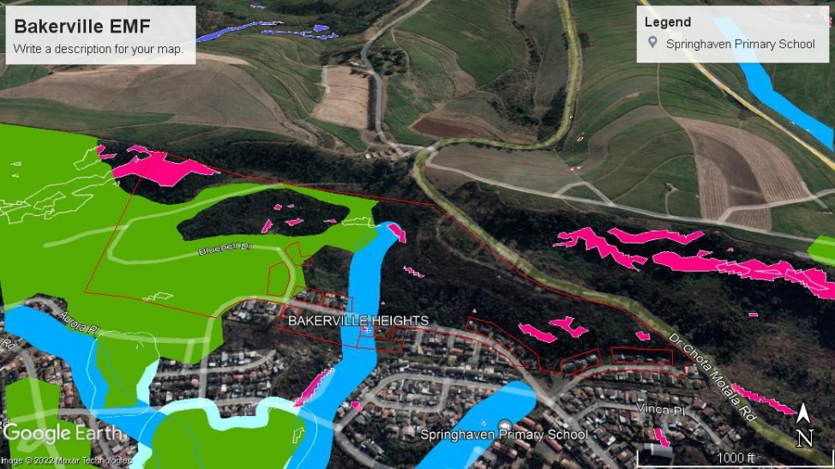

Annexure 1. Msunduzi gazetted EMF

Annexure 2. Msunduzi C - Plan

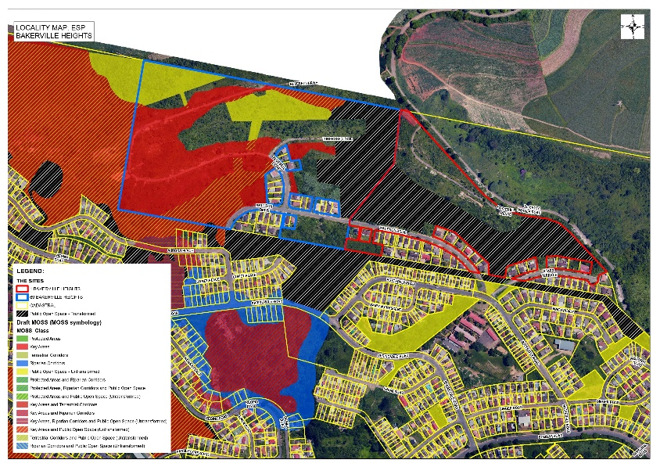

Figure 3. Msunduzi ESP Map

APPENDICES
Appendix 1: Ezemvelo KZN Wildlife C Plan of the minset features occurring on the application site.

