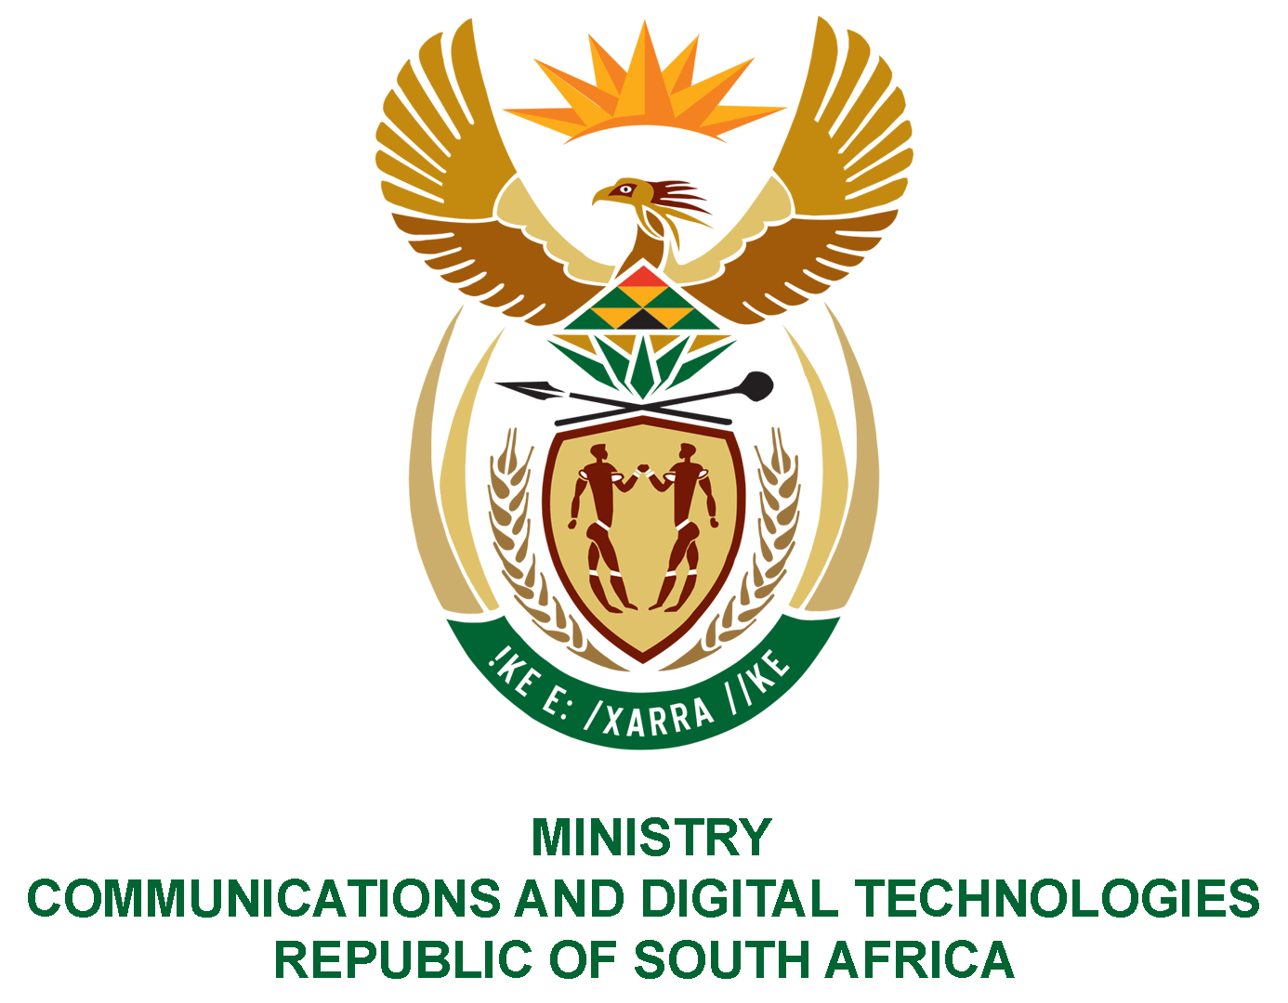
PARLIAMENT OF THE REPUBLIC OF SOUTH AFRICA
NATIONAL ASSEMBLY
WRITTEN REPLY

QUESTION NO: 4621
DATE OF PUBLICATION: 2 DECEMBER 2022
QUESTION PAPER NO: 51

Ms D Kohler (DA) to ask the Minister of Communications and Digital Technologies:
What total amount has her department spent on (a) catering, (b) accommodation, (c) entertainment and (d) travel in the past five financial years?
NW5743E
REPLY:
I have been advised by the department as follows:
(a) | The total amount spent on catering for the period in question was: | R5 766 952.89
(i) | 2019/2020 | R 2 744 476.16
 | Ministry | R 196 362.70
 | Deputy Ministry | -
 | Departmental | R 2 548 113.46
 | BDM | -
(ii) | 2020/2021 | R 637 209.53
 | Ministry | R 51 581.32
 | Deputy Ministry | R 20 000.00
 | Departmental | R 565 628.21
 | BDM | -
(iii) | 2021/2022 | R 838 158.91
 | Ministry | R 157 644.86
 | Deputy Ministry | -
 | Departmental | R 491 384.41
 | BDM | R 189 129.64
(iv) | 2022/2023 (01/04/2022 to 30/11/2022) | R 1 547 108.29
 | Ministry | R 140 988.31
 | Deputy Ministry | R 10 777.20
 | Departmental | R 604 656.58
 | BDM | R 790 686.20
(b) | The total amount spent on accommodation for the period in question was: | R 28 119 012.23
(i) | 2019/2020 | R 8 263 094.12
 | Ministry | R1 846 345.82
 | Deputy Ministry | -
 | Non-Employees | R 217 878.33
 | Departmental | R 6 198 869.97
 | BDM | -
(ii) | 2020/2021 | R 3 842 216.84
 | Ministry | R 871 329.04
 | Deputy Ministry | R 503 138.40
 | Non-Employees | -
 | Departmental | R 2 388 587.19
 | BDM | R 79 162.21
(iii) | 2021/2022 | R 4 621 293.13
 | Ministry | R 1 058 932.02
 | Deputy Ministry | R 568 220.98
 | Non-Employees | R 2 318.55
 | Departmental | R1 382 834.31
 | BDM | R 1 608 987.27
(iv) | 2022/2023 (01/04/2022 to 30/11/2022) | R 11 392 408.14
 | Ministry | R 1 494 650.46
 | Deputy Ministry | R 441 278.88
 | Non-Employees | R 10 884.00
 | Departmental | R 4 964 873.57
 | BDM
(c) | The total amount spent on entertainment for the period in question was: | R 80 524.75
(i) | 2019/2020 | R 78 959.75
 | Ministry | R 18 086.50
 | Deputy Ministry | -
 | Departmental | R 60 873.25
(ii) | 2020/2021 | R 0.00
 | Ministry | -
 | Deputy Ministry | -
 | Departmental | -
(iii) | 2021/2022 | R 1 565.00
 | Ministry | R 1 565.00
 | Deputy Ministry | -
 | Departmental | -
(iv) | 2022/2023 (01/04/2022 to 30/11/2022) | R0.00
 | Ministry | -
 | Deputy Ministry | -
 | Departmental | -
(d) | The total amount spent on travel for the period in question was: | R 70 610 099.10
(i) | 2019/2020 | R 25 701 378.01
 | Ministry | R 6 893 865.39
 | Deputy Ministry | R 9 940.82
 | Departmental | R 18 797 571.80
 | BDM | -
(ii) | 2020/2021 | R 6 463 226.26
 | Ministry | R 1 428 584.94
 | Deputy Ministry | R 942 434.17
 | Departmental | R 3 772 265.87
 | BDM | R 319 941.27
(iii) | 2021/2022 | R 12 715 836.63
 | Ministry | R 3 234 205.42
 | Deputy Ministry | R 1 232 275.89
 | Departmental | R 4 710 109.98
 | BDM | R 3 539 245.34
(iv) | 2022/2023 (01/04/2022 to 30/11/2022) | R 25 729 658.21
 | Ministry | R 4 214 839.83
 | Deputy Ministry | R 1 102 960.23
 | Departmental | R 11 786 035.26
 | BDM | R 8 625 822.89

Authorised for submission by

MS NONKQUBELA JORDAN-DYANI
DIRECTOR-GENERAL (ACTING)
DATE:

Recommended/not recommended

__________________________
HON. PHILLY MAPULANE, MP
DEPUTY MINISTER OF COMMUNICATIONS AND DIGITAL TECHNOLOGIES
DATE:

Approved/ not approved

________________________________
HON. KHUMBUDZO NTSHAVHENI, MP
MINISTER OF COMMUNICATIONS AND DIGITAL TECHNOLOGIES
DATE:

