
Councillor T Colley
Postal Address: P.O. Box 72, KwaDukuza, 4450
Street Address: 14 Chief Albert Luthuli Street, KwaDukuza 4450
Telephone: 082 894 7808
Email: tamsync@kwadukuza.gov.za

8 November 2023

The Municipal Manager
Mr NJ Mdakane

Re: Energy Indaba

Good Day Mr Mdakane

Energy Losses in the Municipality have increased every year, and we have now seen in the latest quarter.
Council resolved that an Energy Indaba was required in order find solutions to this trend.
In light of the fact that the Indaba was scheduled to take place on the 9th and 10th November, I would like to be appraised of the following:
- When will the Indaba be rescheduled?
- What was the reason the Indaba was postponed at the very last minute?
- Has there been any cost incurred to council due to this postponement?

Yours sincerely
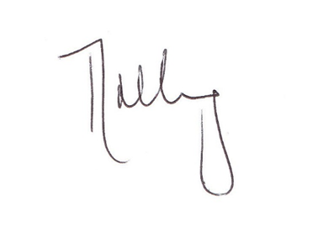
Cllr T. Colley

