09 May 2024

Ms Busisiwe Mashigo

ICASA
Block B,
350 Witch-Hazel Ave
Eco-Park Estate
Centurion
0144

Dear Madam,

Rejection of Democratic Alliance’s TV Advertisement

- The SABC informs the Independent Communications Authority of South Africa (ICASA) of its decision to reject the Democratic Alliance’s (DA) political advertisement in which amongst other things depicts the burning of the national flag.

- The SABC has been monitoring the outcry from South Africans of all races condemning the advertisement which is currently in circulation on various media platforms. Likewise, the SABC believes that the advertisement encourages damage of treasured national symbols. The national flag is a national symbol which represents diverse elements of the country and national unity. Additionally, it is expected that the national flag should be accorded with dignity and respect. Thus, the flag is not a representation of a political party but the nation at large.

- The SABC has also noted the condemnation of the advertisement by the President of the Republic and other government departments.

- As a responsible public broadcaster, the SABC will not want to be part of fuelling the outrage that is evidenced on divergent media platforms.

- The SABC persuades the Democratic Alliance to amend the advertisement.

- In the spirit of the South African Constitutional values and principles of national unity and nation building, the desecration of the national flag should be condemned.

- The SABC, as a public broadcaster, is mandated to promote nation building through its services and the said political advertisement goes against the spirit of nation building.

- The SABC has also noted that some of the words used in the advertisement in question are subject to a formal complaint lodged with ICASA against the SABC. Therefore allowing this advertisement to be broadcast will be prejudicial to the SABC.

We encourage the DA to amend the advertisement and resubmit for broadcast.

Regards,

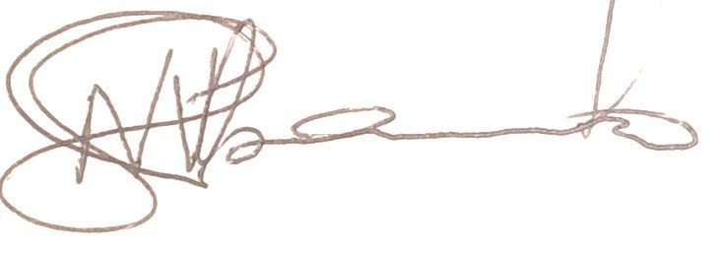
NYIKO SHIBAMBO
Complaints Specialist
SABC

