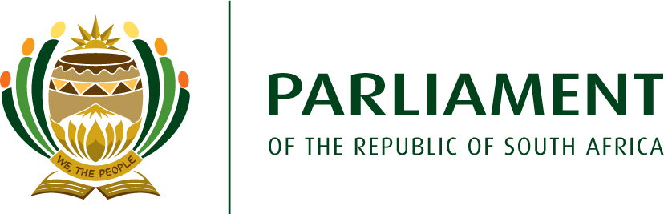**NATIONAL ASSEMBLY MEMBER OF PARLIAMENT**

**9**

PO Box 15 Cape Town 8000 Republic of South Africa

Cell: 083 251 5613

Email: tchance@parliament.gov.za

[www.parliament.gov.za](http://www.parliament.gov.za/)

[www.da.org.za](http://www.da.org.za/)

TOBY CHANCE, MP

SPOKESPERSON TRADE, INDUSTRY AND COMPETITION

**DEMOCRATIC ALLIANCE**

Hon Parks Tau, MP

Minister of Trade, Industry & Competition

77 Meintjies Street

Sunnyside

Pretoria

Gauteng

0002

Ministry@thedtic.gov.za

6th August 2024

Dear Minister Tau

**Request resolve serious governance issues at the SABS**

In the past week I have been contacted by an individual, who wishes to remain anonymous, who is in possession of information alleging very serious transgressions involving senior management at the SABS, as well as a lack of governance affecting the board of directors.

The allegations, inter alia, state that:

* The SABS is being run illegally, in that there is no Board chairperson, there needs to be a minimum of 7 board members and there is currently only 5 and there are decisions being made without the Minister authorizing them.
* The current change of Acting CEO is illegal as there could be no Board resolution as there is no quorum or any approval by the Minister.
* The Board has deliberately not appointed a CEO in the last 18 months so that they can revolve and rotate the current executives so that accountability for corruption is shifted.  The Minister needs to urgently intervene.  This rotation is causing confusion amongst all stakeholders and enables the non-performance of the organization.
* The SABS has lost accreditation of its cement labs for the second time and the acting CEO has removed all accountability from himself by suspending the levels that are lower than him.
* The collapse of the performance management system and processes for the last EIGHT years is deliberate to keep the dysfunction so that the executives and the Board keep looting.
* It seems as though the current Acting CEO who was previously in charge of Human Capital has a strategy of only employing people from the Eastern Cape, including consultants that are lawyers.
* There is no governance system at the SABS.  The process of policy-making and review is defunct, along with performance management and the executive keep chopping and changing competent employees to replace them with incompetence so that irregularities can continue to happen.

With the government of national unity’s stated intention of rooting out corruption and mis-governance at state entities very much in mind, I am sure you will take any allegations of corruption or maladministration within the dtic and its entities seriously.

I call on you to resolve the serious lack of governance at the SABS, as alleged above, as a matter of urgency, and upon verifying that the allegations are correct, appoint two additional directors to the board, as well as a permanent chair.

I have written to Acting Director General Ms Malebo Mabitje-Thompson, in her role as accounting officer of the dtic responsible for the department’s entities, calling her to launch an independent investigation into the broader allegations without delay.

The SABS performs vital functions in the South African economy, providing services to industry that directly impact companies’ competitiveness in local and global markets. Having placed the SABS under administration in 2018, former Minister Rob Davies began a process of renewal but clearly this has stalled.

The DA will be scrutinising the actions of the Department and Ministry to ensure these issues are dealt with effectively and timeously.

I look forward to hearing from you.

Yours sincerely

Toby Chance, MP

DA Spokesperson on Trade, Industry & Competition