**Public Service Commission presentation to SCOPA:**

**Financial misconduct cases**

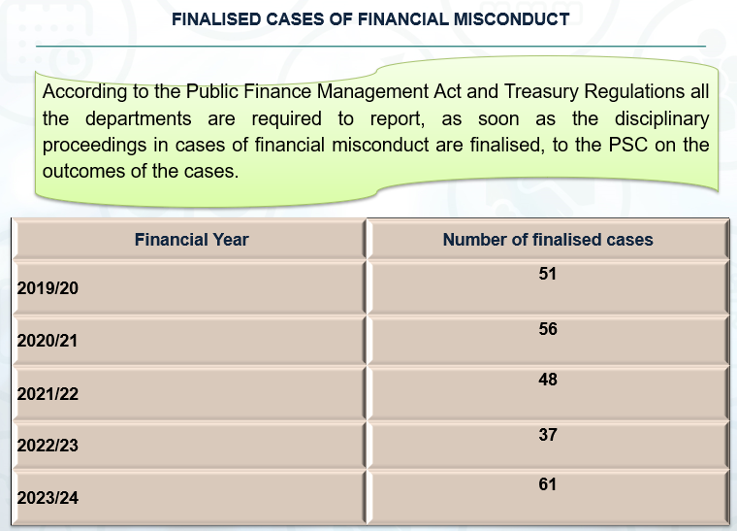

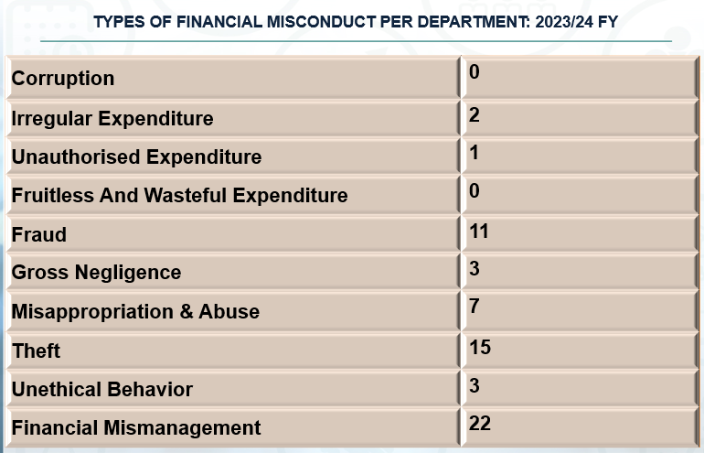

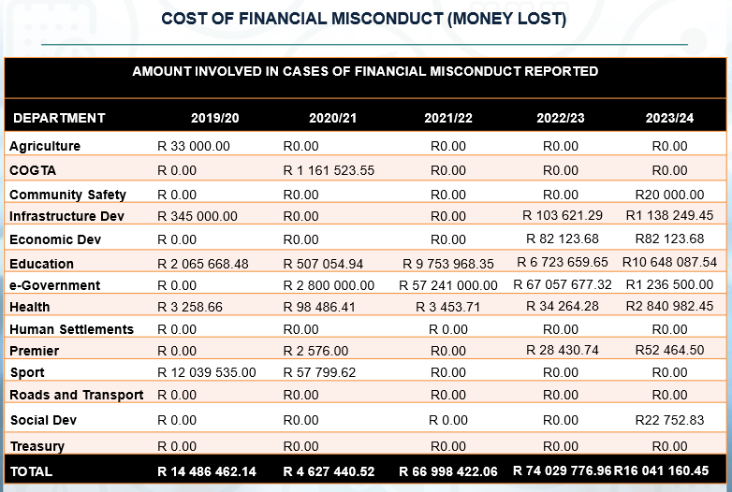

In regards to finalised cases of financial misconduct, the PSC observed the following:

* That there has been underreporting by HoDs in respect of the finalised cases of financial misconduct considering the concluded investigations which were conducted by various law enforcement agencies and forensic service providers.
* That over the years the recovery rate has always been low, and the trend has been writing-off of the debts because of loss of records, unjustifiable delays through litigations etc.
* The Premier’s Office should therefore ensure that its recovery strategy on monies lost by the province is effectively and efficiently implemented to reflect the correct amount and tracking actual recovery across all the Departments and its entities.
* That in the 2023/24 financial year, 23 employees who were dismissed because of financial misconduct which is more than previous financial years.