**NATIONAL ASSEMBLY**

**QUESTION: 1379**

**FOR WRITTEN REPLY**

**DATE OF PUBLICATION IN INTERNAL QUESTION PAPER: 18 OCTOBER 2024**

**(INTERNAL QUESTION PAPER NO. 16)**

**Mrs M O Clarke (DA) to ask the Minister of Health:**

(1) What (a) total number of claims was each of the companies (names furnished) involved in in each province to deal with medico-legal claims against his department, for which an amount of R72 million was provided by the National Treasury in 2019 and (b) number of claims against his department was each of the specified firms involved in;

(2) what (a) was the total monetary value of claims for each of the companies, (b) was the value of each individual claim, (c) was the total cost of legal proceedings and (d) the total legal cost for each claim, (d) in which provinces were they each appointed and (e) was reason of their appointment? **NW1707E**

**REPLY:**

1. (a), (b) and 2 (a) The responses are in the Tables below. The responses for 1 (a) and (b) are the same.

|  |  |  |
| --- | --- | --- |
| **HANDLING OF MEDICO-LEGAL CLAIMS: CAJV** | | |
| Province | Total number of claims for each Company **1 (a) and (b)** | Total monetary value of claims for each Company **2 (a)** |
| Gauteng | 1041 | R 7 991 595 621.50 |
| Mpumalanga | 144 | R 1 382 612 519.07 |
| Limpopo | 139 | R 921 694 666.48 |
| **Totals** | **1324** | **R 10 295 902 807.05** |

|  |  |  |
| --- | --- | --- |
| **HANDLING OF MEDICO-LEGAL CLAIMS: NORTON ROSE** | | |
| Province | Total number of claims for each Company **1 (a) and (b)** | Total monetary value of claims for each Company **2 (a)** |
| Eastern Cape | 472 | R 6 869 509 291.88 |
| KZN | 155 | R 2 648 808 149.47 |
| Northern Cape | 79 | R 971 388 755.00 |
| **Totals** | **706** | **10,489,706,196.35** |

|  |  |  |
| --- | --- | --- |
| **FORENSIC INVESTIGATIONS: INTEGRATED FORENSIC ACCOUNTING SERVICES (PTY) LTD** | | |
| Province | Total number of claims for each Company **1 (a) and (b)** | Total monetary value of claims for each Company **2 (a)** |
| Gauteng | 398 | R 5 347 380 257.00 |
| Norther Cape | 42 | R 916 921 241.00 |
| **Totals** | **440** | **R 6 264 301 498.00** |

|  |  |  |
| --- | --- | --- |
| **FORENSIC INVESTIGATIONS: DELLOITE** | | |
| Province | Total number of claims for each Company **1 (a) and (b)** | Total monetary value of claims for each Company **2 (a)** |
| KwaZulu Natal | 36 | R 371 163 685. 55 |
| **Totals** | **36** | **R 371 163 685. 55** |

**ABACUS FCA Pty** has been appointed todevelop and maintain the Case Management System. In light of the above, 1 (a) and (b) and 2 (a), (b), (c) and (d) are not applicable to **ABACUS.**

1. (c) and (d)[1] - The response is in the table below.

|  |  |
| --- | --- |
| **PAYMENTS MADE BY THE NDOH TO SERVICE PROVIDERS FOR ASSISTING THE PROVINCES IN HANDLING MEDICO- LEGAL CASES** | |
| **SERVICE PROVIDERS** | **TOTAL AMOUNT PAID** |
| **CAJV** | R 83 357 451.12 |
| **NORTON ROSE FULLBRIGHT SA** | R 92 049 424.59 |
| **TOTAL** | R 175 406 875.71 |

(2) (d) [2] The five Service Providers were allocated services and Provinces as per the Table below.

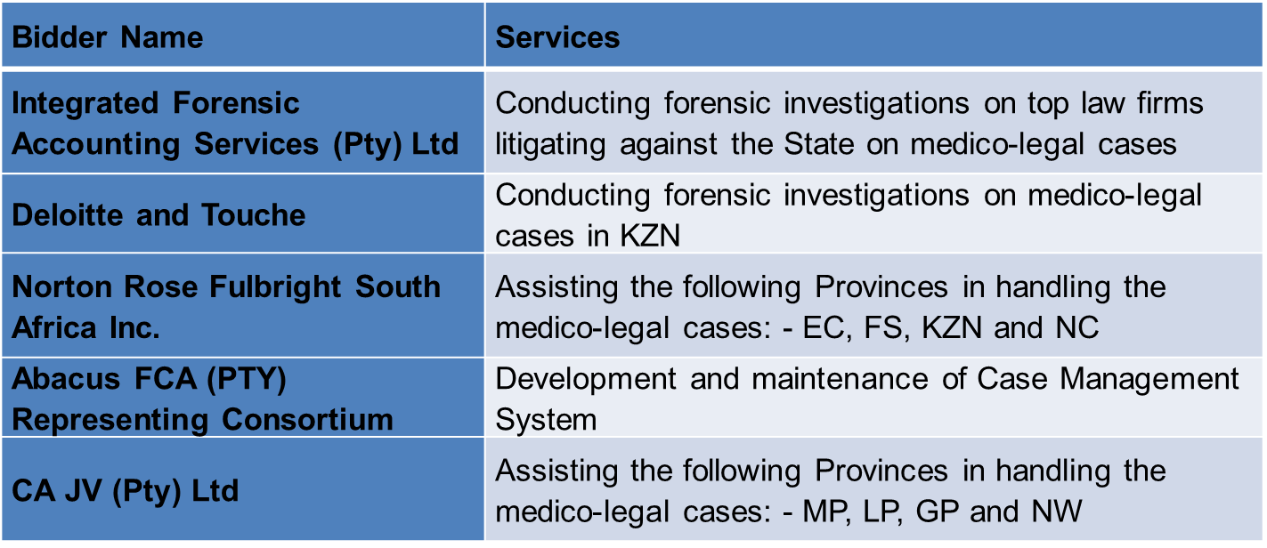

(e) The National Health Council (NHC) has approved a Medico-Legal Transversal Tender implementation. In light of the NHC decision, the Tender was advertised in the Tender Bulletin of Friday the 14 September 2018 as Tender Number NDOH 29/ 2018-2019 with the closing date of 15 October 2018. The Briefing Session was held on 21 September 2018.

The Heads of Departments of all the Provincial Departments of Health with the exception of the Western Cape (indicated that they are not participating in the transversal tender) were requested to release their Heads of Legal Services or Medico-Legal units to participate in the Bid evaluation. 52 bids were received and four were disqualified due to the non-attendance of the compulsory briefing session. The bids were then evaluated from the 29 October - 02 November 2018.

END.

1. There are two (d) in the third question and this is the response to the first (d)
2. There are two (d) in the third question and this is the response to the second (d)