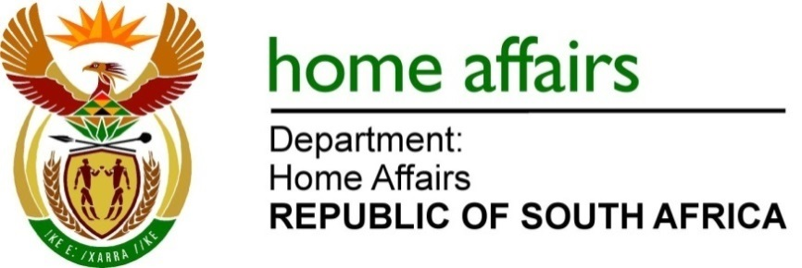

NATIONAL ASSEMBLY

QUESTION FOR WRITTEN REPLY

QUESTION NO. 1778

DATE OF PUBLICATION: Friday, 4 April 2025

INTERNAL QUESTION PAPER 14 – 2025

1778. Mr A C Roos (DA) to ask the Minister of Home Affairs:

(a) What was the number of internal immigration enforcement operations in quarter 4 in the (i) 2023-24 and (ii) 2024-25 financial years and (b) are the reasons for the year-on-year increase or decrease in immigration enforcement operations in quarter 4 in the specified financial years? NW1991E

REPLY:

(a) Immigration enforcement operations in Quarter 4 as per financial year:
(a)(i) FY 2023-24 = 383
(a)(ii) FY 2024-25 = 1 415

(b) The increased number of immigration enforcement operations as reported reflects the Department’s commitment to upholding the rule of law. It further results from national interventions by the NATJOINTS structures, to deal with illicit mining as well as the food borne disease interventions. The Department executes its mandate as part of both interventions, with the focus on illegal immigrants in the respective sectors.
END.

