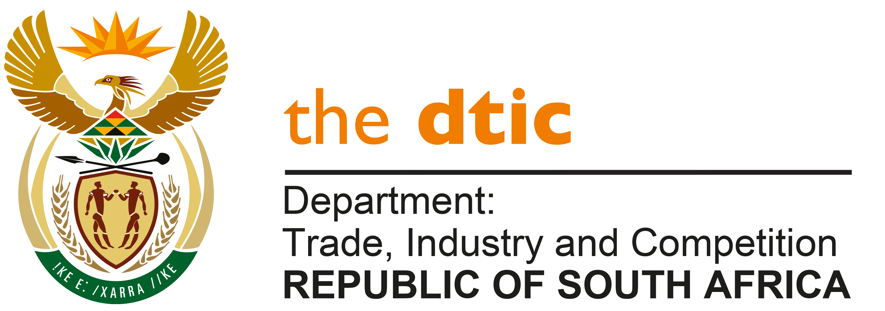

**THE NATIONAL ASSEMBLY**

**QUESTION FOR WRITTEN REPLY**

**QUESTION NO. 1220**

**MP Mr R W T Chance (DA) to ask the Minister of Trade, Industry and Competition:**

(a) What total number of trade counsellor positions are currently vacant in each country where the Republic has an embassy, high commission and/or trade office, (b) for how long has each trade counsellor position in each (i) embassy, (ii) high commission and (iii) trade office been vacant and (c) in which country is each specified (i) embassy, (ii) high commission and (iii) trade office that has a vacancy? NW1363E

**REPLY:**

(a) The Department of Trade, Industry and Competition (**the dtic**) is responsible for the overall management of 45 trade offices across the globe, tasked with stimulating global demand for South Africa’s manufactured goods and services and attracting Foreign Direct Investment (FDI) into South Africa.

These trade offices are located within South African missions abroad, which include High-Commissions, Embassies and Consulates General. The total number of vacant trade counsellors, referred to as Foreign Economic Representatives (FERs), comprise of 30 positions in South African missions abroad.

(b, i, ii, iii) Since the return of the last FERs during December 2023, all trade offices have remained vacant, with the exception of the Geneva office which is staffed with 4 officials. The department has been going through a review of the approach to the FERs and the footprint of markets where they will be deployed, with a process of appointing FERs to key identified trade offices poised to start.

(c, i, ii, iii) The location of the indicated FER vacancies are as follows:

| **Country** | | **High Commission, Embassy or Consulate General** |
| --- | --- | --- |
| 1 | Ethiopia | Addis Ababa |
| 2 | Zimbabwe | Harare |
| 3 | China | Shanghai |
| 4 | China | Beijing |
| 5 | Germany | Munich |
| 6 | Kenya | Nairobi |
| 7 | Nigeria | Abuja |
| 8 | Ghana | Accra |
| 9 | Mozambique | Maputo |
| 10 | United Kingdom | London |
| 11 | Senegal | Dakar |
| 12 | Democratic Republic of Congo | Kinshasa |
| 13 | Japan | Tokyo |
| 14 | Angola | Luanda |
| 15 | United States of America | Washington |
| 16 | Brazil | Sao Paulo |
| 17 | United Arab Emirates | Dubai |
| 18 | India | New Delhi |
| 19 | India | Mumbai |
| 20 | Belgium | Brussels |
| 21 | Saudi Arabia | Riyadh |
| 22 | Germany | Berlin |
| 23 | Russia | Moscow |
| 24 | Algeria | Algiers |
| 25 | Uganda | Kampala |
| 26 | South Sudan | Juba |
| 27 | Egypt | Cairo |
| 28 | Iran | Tehran |
| 29 | France | Paris |
| 30 | South Korea | Seoul |

**-END-**