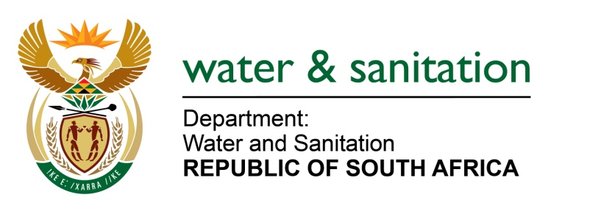

NATIONAL ASSEMBLY

FOR WRITTEN REPLY

QUESTION NO 6984

DATE OF PUBLICATION IN INTERNAL QUESTION PAPER: 21 NOVEMBER 2025 (INTERNAL QUESTION PAPER NO 52)

6984. Mr S J Moore (DA) to ask the Minister of Water and Sanitation:
What total amount did each water board in the Republic spend on advertising in each of the past three financial years?
NW7816E
---00O00---
MINISTER OF WATER AND SANITATION

The details of expenditure by water boards on advertising in the past three financial years are indicated in the table below:

Water Board | 2024/2025 | 2023/2024 | 2022/23
Magalies Water | R764 183, 55 | R623 394,16 | R592 680, 00
Overberg Water | R0 | R0 | R0
Amatola Water | R309 232, 00 | R408 728. 00 | R542 704, 00
Vaal Central Water | R0 | R0 | R0
Lepelle Northern Water | R225 151,19 | R189 956,88 | R156 476, 60
Rand Water | R24 734 000 | R20 000 000 | R20 000 000
uMngeni-uThukela | R5 953 199 | R3 939 296 | R6 309 816
TOTAL | R31 985 765, 74 | R25 161 375, 04 | R27 601 676
---00O00---

