I Hon. Solly Msimanga table the following motion to censure in terms of Rule 121 read with Rule 117 (2) (b):

Concerning the need for responsible spending and substantive outcomes when members and staff of the Gauteng Provincial Legislature go on overseas trips, the following motion is submitted in terms of Rule 117 (2) (b) concerning the censure of a body or person:

Noting:

- The trip to Venezuela that departed on 27 November 2025 with the Honourable Speaker Morakane Mosupyoe, four other members and seven staff, at a total cost of R5 997 895, broken down as follows:

Item | Amount
Air travel | R3 274 819
Accommodation | R931 870
Transport | R251 717
Travel services | R33 840
Per diem | R1 505 651
Total | R5 997 895

- with each person pocketing a per diem of about R125 000 each;

- The claimed outcome being participation in the International Tourism Fair of Venezuela (FITVEN) with South Africa being recognised as the Guest of Honour country, including a GPL exhibit alongside BrandSA which "deepened diplomatic relations and soft-power international relations between Gauteng and its counterparts" and "cemented the expressions of solidarity and mutual respect, with participation serving to enhance the dialogue and exchange that the FITVEN was designed to foster"; and

- The discrepancy between the dates of FITVEN which ran from 28 November to 1 December and the 12-day duration of the trip according to an official reply by the Provincial Secretary to the OCPOL Committee;

And Believing:

- That this was an unjustifiably large delegation for a four-day tourism conference which already had a BrandSA exhibit;
- That the claimed outcomes are vague and of extremely limited benefit for the people of Gauteng, many of whom have unmet basic needs; and
- That the rest of the 12-day trip is disturbingly unexplained and cannot have any conceivable justification except as a jaunt for members to pick up extra per diem payments;

Therefore:

This House censures the Honourable Speaker Morakane Mosupyoe for appalling judgement and a disgraceful waste of a large amount of money that puts personal benefit before the interests of the people of this province.

The motion to censure is proposed by:

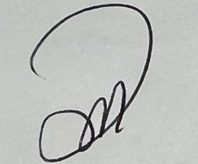
_________________________________________

Solly Msimanga

Seconded by:

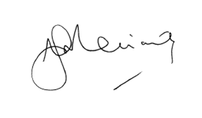
________________________________________

Mike Moriarty

